The SENNEBOGEN 355 E telehandler demonstrates its full potential at a composting plant in England

Telehandler or wheel loader? The SENNEBOGEN 355 E telehandler offers the best of both worlds. The machines powerful bucket operation combined with a long reach is ideal for work in a composting plant. Only available from SENNEBOGEN, the elevating cab ensures that the operator can work safely and comfortably.

Steaming mounds of earth, taller than a person, in different shades of brown, arranged in windrows, framed by green fields and narrow streets - this is what Nigel Baker's work site looks like. At his composting plant near Bridgwater, England, he produces high-quality compost from biogenic waste under the name "Nigel Baker Ltd." SENNEBOGEN sales and service partner Molson Group from Bristol were delighted to help him decide that the SENNEBOGEN 355 E telehandler was the right machine for the job.

Despite the rain, once again it is time for Nigel Baker to turn over the raw material on site. Regularly restacking the material encourages stable and homogeneous compost and ensures that the gases and heat produced by the composting process can escape. Depending on the maturity and moisture content of the material, it can weigh up to around two tons per cubic meter. A task tailor-made for the SENNEBOGEN 355 E telehandler.

Strong and robust like a wheel loader – long reach and sturdy like a telehandler.

The clever combination of telehandler and wheel loader technology means that with 85 kN it has more than enough break-away force and sufficient reach to rotate and stack the enormous piles of heavy, damp compost using the appropriate soil shovel. Nigel Baker is impressed, "For my work, I need a machine that has both a high reach and can withstand the demands of heavy loading and unloading work. The SENNEBOGEN 355 E provides both in one machine."

Several weeks of regular rotation turns the raw material into fine-grained, high-quality compost. Once it is ready, it is loaded into containers for transportation by truck. The elevating cab means that Nigel Baker can see right into the containers and so can ensure that he loads them efficiently. "The elevating cab is unparalleled. I have a fantastic view when I am working and can adjust the height to my requirements. The vibration damping means that I can sit comfortably and stably at the view height I need and can concentrate on my work without distraction," says Nigel Baker. The containers can be loaded very quickly. Baker estimates that it takes him five minutes to fully load a container.

Once again the SENNEBOGEN telehandler proves that it is more than just a standard telehandler.

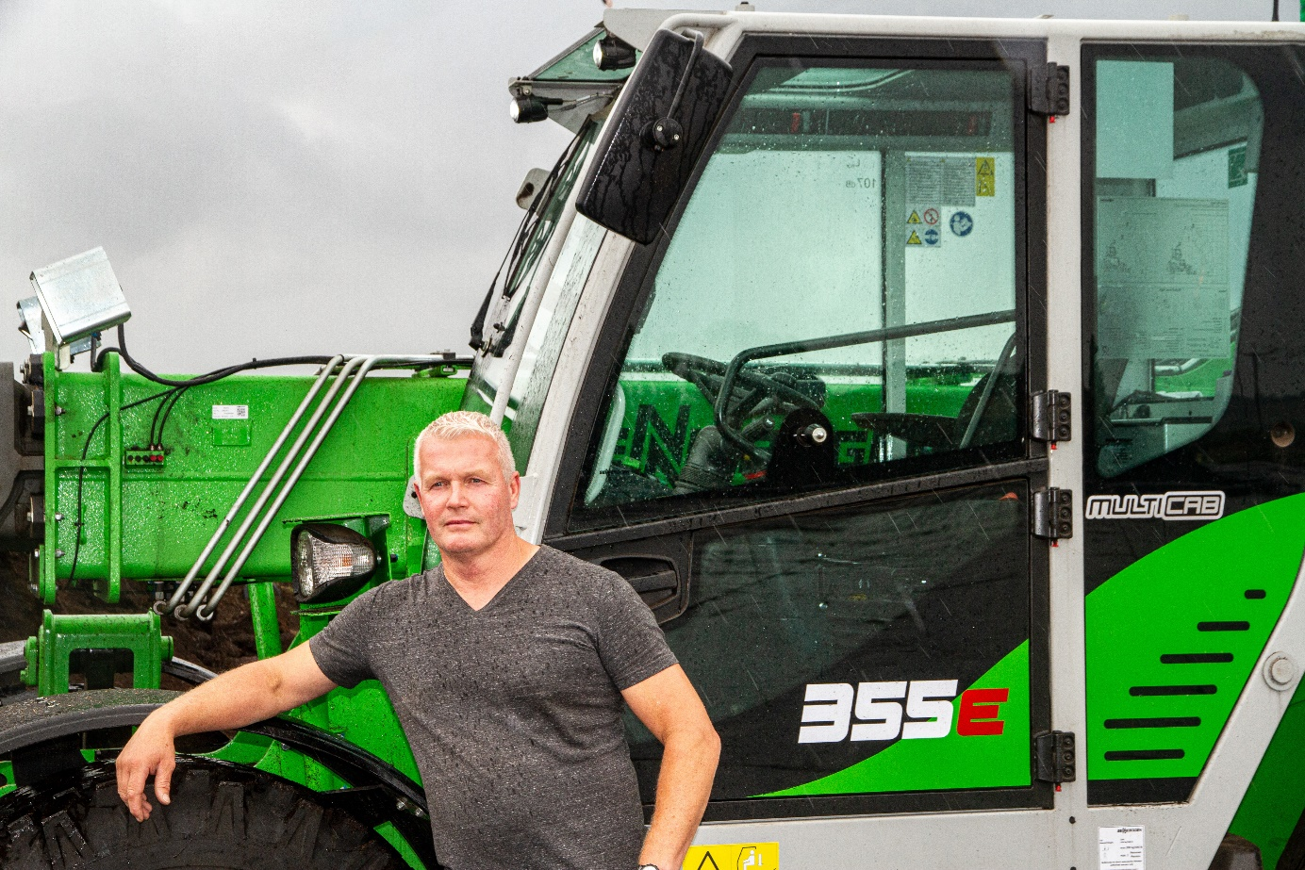
Nigel Baker, owner of Nigel Baker Ltd., in front of the SENNEBOGEN telehandler

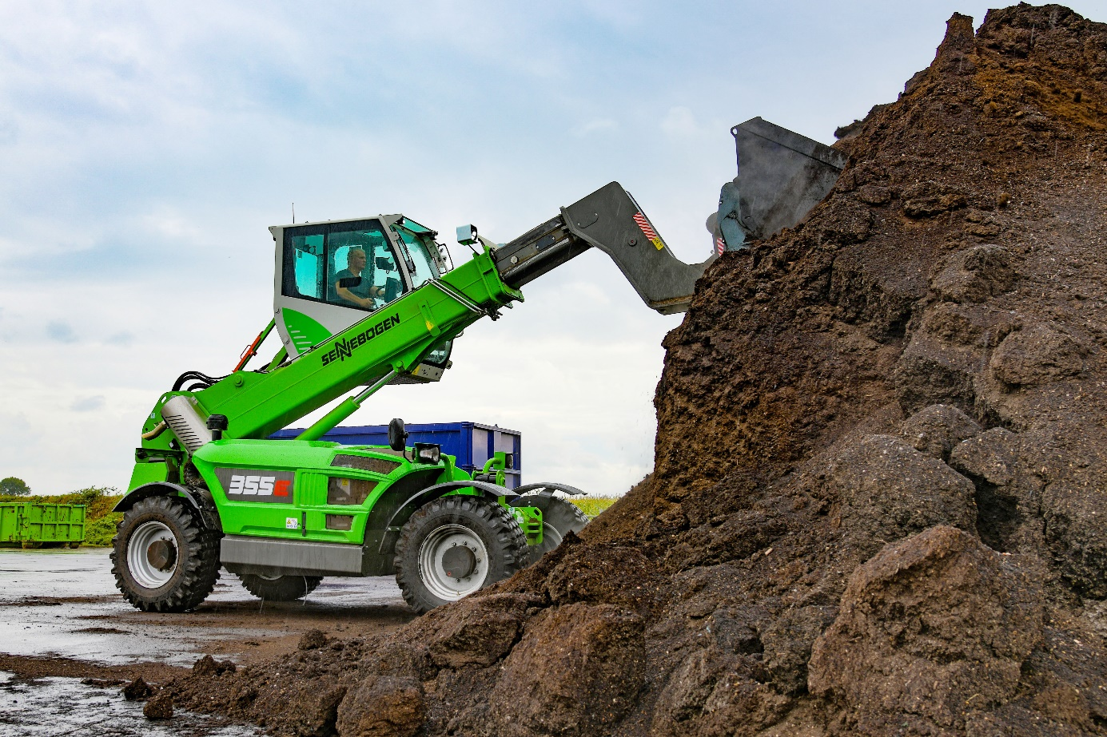
High reach and break-away force play an important role when it comes to loading
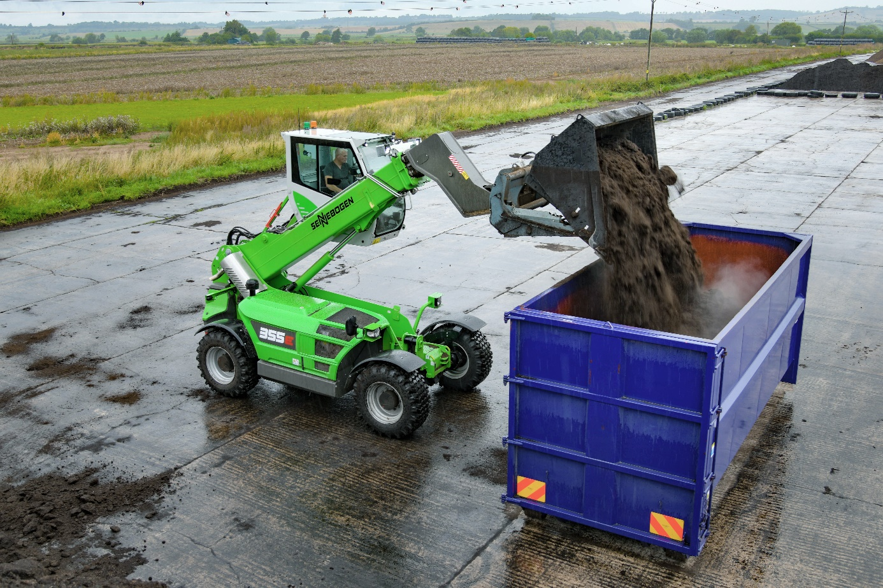
The elevating cab means the operator can always see their work

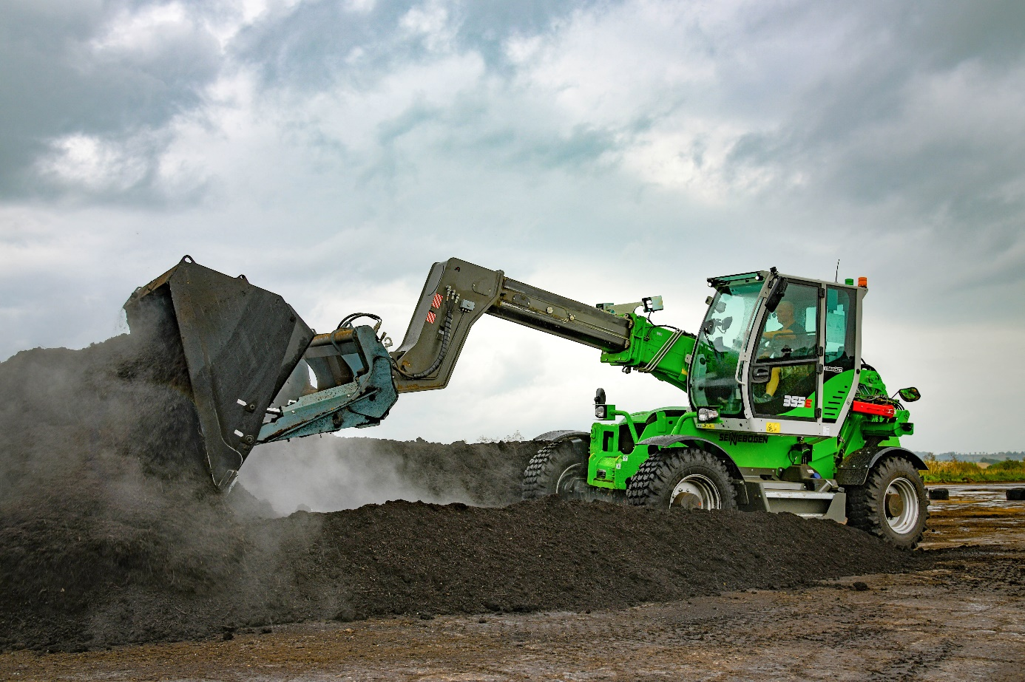
The compost can be rotated easily thanks to the robust telescopic arms.

