Editor Autor: Geert-Yke Rusticus | Photo Foto: Bouwmaterieel Benelux | Location Ort: Leeuwarden | Date Datum: Nov-20

Telehandler instead of wheel loader: Total Recycling Industries, in the Netherlands, uses the SENNEBOGEN 355 E

TRI (Total Recycling Industries) has a recycling facility on the Leeuwarden industrial park in the Netherlands which handles around 250,000 car and truck tires each year. The company has a specific shredder it uses to turn the tires (a total of around 5,000 t) into granulate. The granulate is used as a recycled fuel for cement production plants. For the first time, TRI has chosen to use a SENNEBOGEN 355 E telehandler instead of a wheel loader to load tires and feed the shredder.

TRI collects tires mainly from the northern provinces and has been doing so for almost 20 years. In order to do this, the company has its own truck, trailer and container. Until recently, the tires had been loaded and the shredder fed with the help of a 10 ton wheel loader, but its 20 years of service came to an end. There were a number of decisive factors in choosing a new machine for this daily operation. When feeding the shredder and loading the trucks, a good view is essential. The machine also needs to be powerful and have sufficient capacity. In addition, good stability is also important. The company premises are not huge, so compact dimensions and maneuverability are also key elements.

The SENNEBOGEN 355 E telehandler caught the attention of TRI’s Wilfred Pol as it met all these criteria and seemed the ideal machine for this type of work. “In this sector there are only a few 10 to 11 t wheel loaders to choose from. And, with a wheel loader, the view when feeding the shredder and loading high trucks is quite limited. Whereas a standard telehandler is not generally powerful enough and does not have sufficient capacity.” Prior to the purchase, SMT, SENNEBOGEN’s sales and service partner in the Netherlands, provided a test machine for TRI to use. This enabled the company to make a fully informed choice. SENNEBOGEN’s telehandler concept quickly impressed TRI and the decision to purchase was made.

Unique concept – the best of both telehandler and wheel loader technology
The SENNEBOGEN 355 E weighs around 11.8 t and is a special machine that combines the features and benefits of both wheel loaders and telehandlers in one unique concept. This means that the telehandler is particularly well-suited to the recycling industry where wheel loaders, telehandlers and material handlers are frequently used. However, this concept is not just ideal for the recycling industry, but also for other industrial applications where heavy lifting work needs to be done. On building sites, the 355 E can be used to transport building materials.

Both the chassis and the telescopic arm are solid and robust, meaning they can handle large forces. Thanks to its unique Z kinematics, a feature of many wheel loaders, the 355 E provides at least 50 % more break-away force than standard telehandlers in the same weight class. This gives the telehandler the power and characteristics of a wheel loader and, thanks to the boom structure, a bigger work area and greater working height. The 355 E telehandler from SENNEBOGEN is the perfect alternative to small material handlers and wheel loaders with tipper buckets.

Furthermore, the 355 E stands out from other material handlers and telehandlers on the market due to its series standard hydraulically elevating cab, which provides the optimal view for any application. At full height the operator has a view height of 4.25 m. The SENNEBOGEN Multicab boasts plenty of glass and slimline door posts and window frames, giving the operator a clear all-round view. At compact recycling facilities, where people work in close proximity to machines and there are lots of trucks moving around, this clear view significantly increases occupational safety. Being able to guarantee such safe and efficient loading of sliding floor trailers, containers and shredders is a real advantage for TRI. Also, the elevated view means operators can see into trucks and better distribute material when loading. This was difficult to do with a wheel loader.

Robust, stable and multi-functional
The 355 E stands out for the robust structure of its telescopic boom. Its shape and structure were designed with heavy duty recycling work in mind. The sliding blocks are precisely positioned and can withstand high forces. They, therefore, prevent the extended boom from twisting when traveling with a large volume of waste or scrap, or when unloading at great heights. This can be seen in practice at the Leeuwarden recycling facility. With a bucket full of tires and the telescopic arm extended, the 355 E is powerful enough to both move a tire stack and push tires together.

The telehandler is equipped with the additional functions required to work with different attachments. Changing attachments is quick and easy thanks to the hydraulic quick change system. TRI uses various attachments with the machine including a high-volume bucket with a load capacity of 3.6 m³ and a 4.5 m wide rubber slider which is used to push tires or granulate into piles and also to keep the premises clean and tidy. The company also has a fork carrier with wide forks and a special custom-made attachment for transporting containers and even the tire shredder.

Nokian Tri Steel 500/70 R24 steel-reinforced tires were chosen for driving across the paved surfaces of the premises. SENNEBOGEN supplies different types of tires depending on application and location. Under any conditions, the 355 E should handle well, have good off-road mobility and be sufficiently comfortable.

Thanks to its heavy duty axles, the machine is ideally suited to tough working conditions, for example loading heavy loads with a fully extended telescopic arm. Its thrust and traction forces of up to 85 kN are impressive. Nevertheless, the SENNEBOGEN 355 E telehandler offers a very pleasant and comfortable ride, with a maximum traveling speed of 40 km/h. The 355 E is very agile and, thanks to its compact dimensions, has a turning circle of under 4 m – an important feature for TRI. In addition, it can be driven with all-wheel drive or with crab steering. This makes the SENNEBOGEN telehandler ideally suited for use at locations with limited space.

The 355 E telehandler is a perfect machine for recycling companies and, for TRI, is a vast improvement compared with a wheel loader. The SENNEBOGEN can be used in a multitude of ways as a wheel loader, a telehandler and a material handler, it is economical with fuel and has high thrust and traction. The elevating cab also gives the operators a perfect view of the shredder or the truck being loaded. This leads to improved productivity, efficiency and safety. The SENNEBOGEN 355 E is a real asset to TRI in so many ways!

Text translated and revised from Dutch. Text and pictures with the kind permission of Geert-Yke Rusticus, Editor of the “Bouwmaterieel Benelux” magazine.

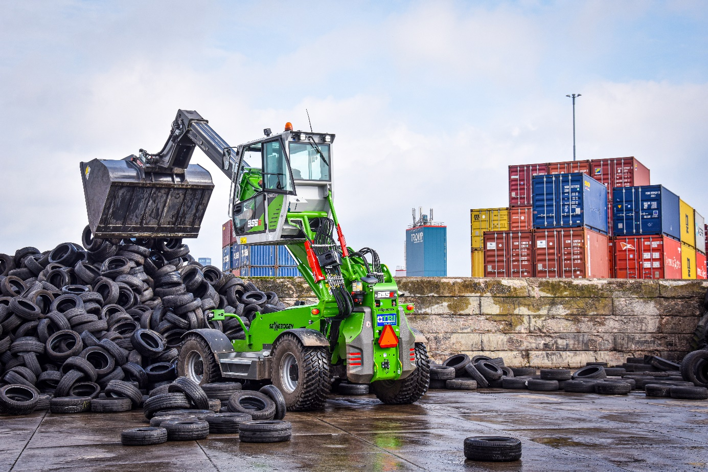
The SENNEBOGEN 355 E telehandler is versatile and can be used as a telehandler, a wheel loader or a compact material handler.

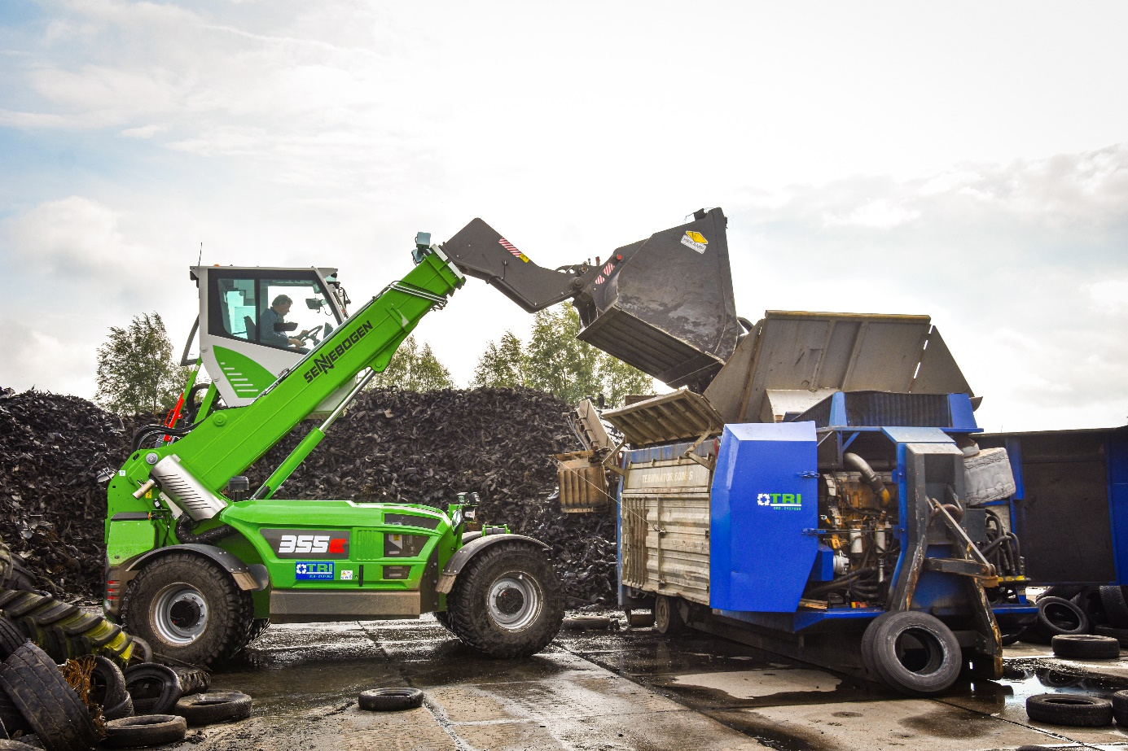
The high-volume bucket being used here has a load capacity of 3.6 m³.

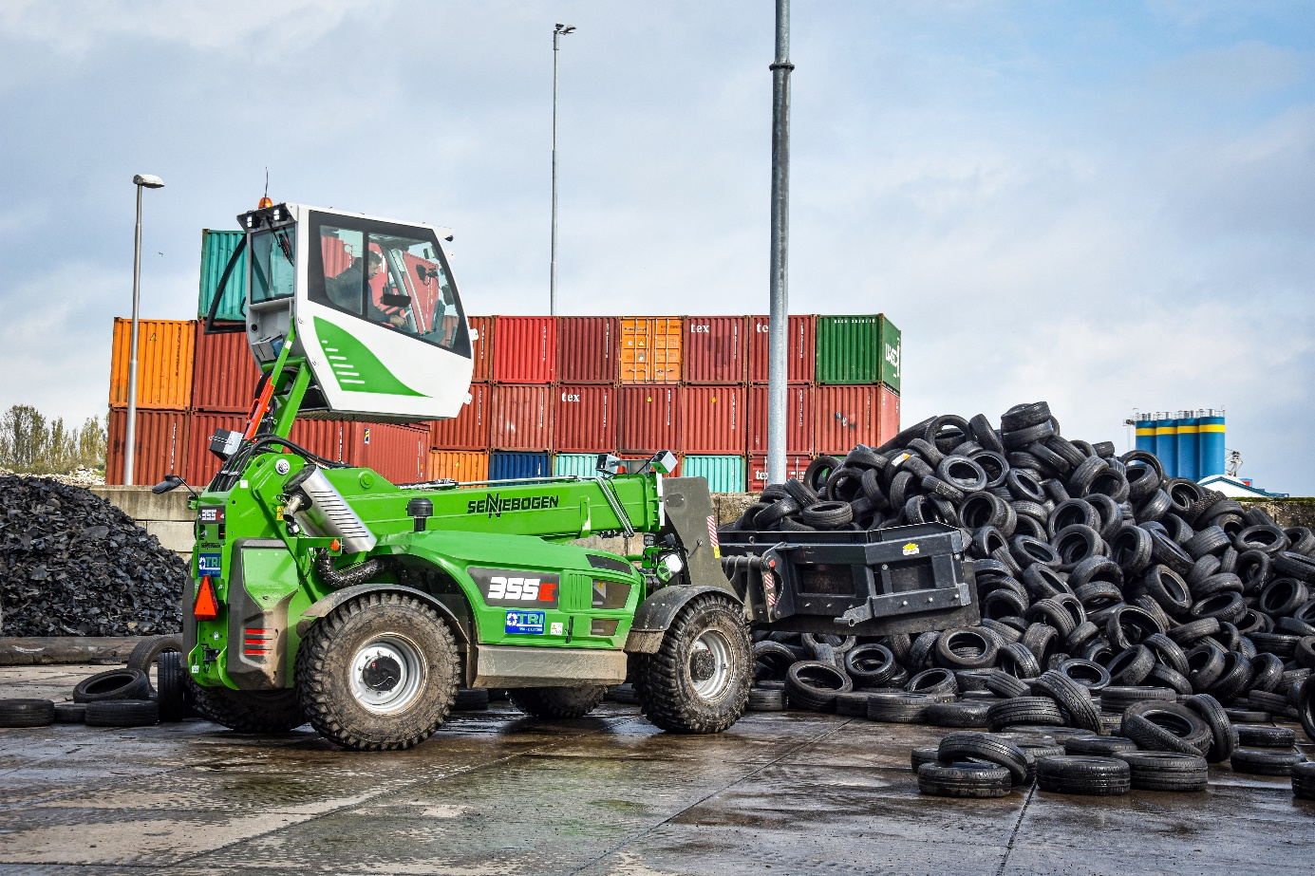
The telehandler being used with a 4.5 m wide rubber slider to push the tires.

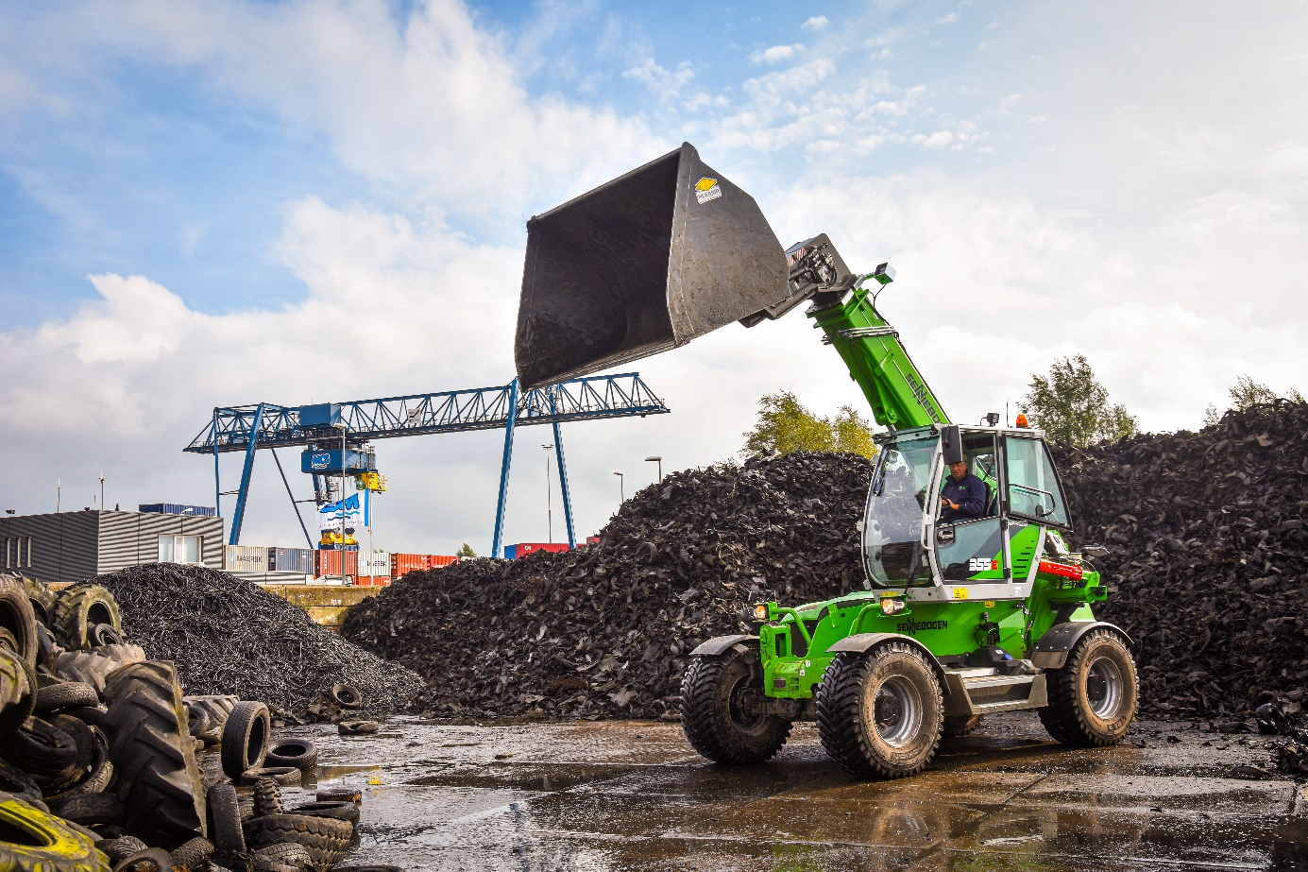
The 355 E combines the benefits of a telehandler and a wheel loader in one unique machine

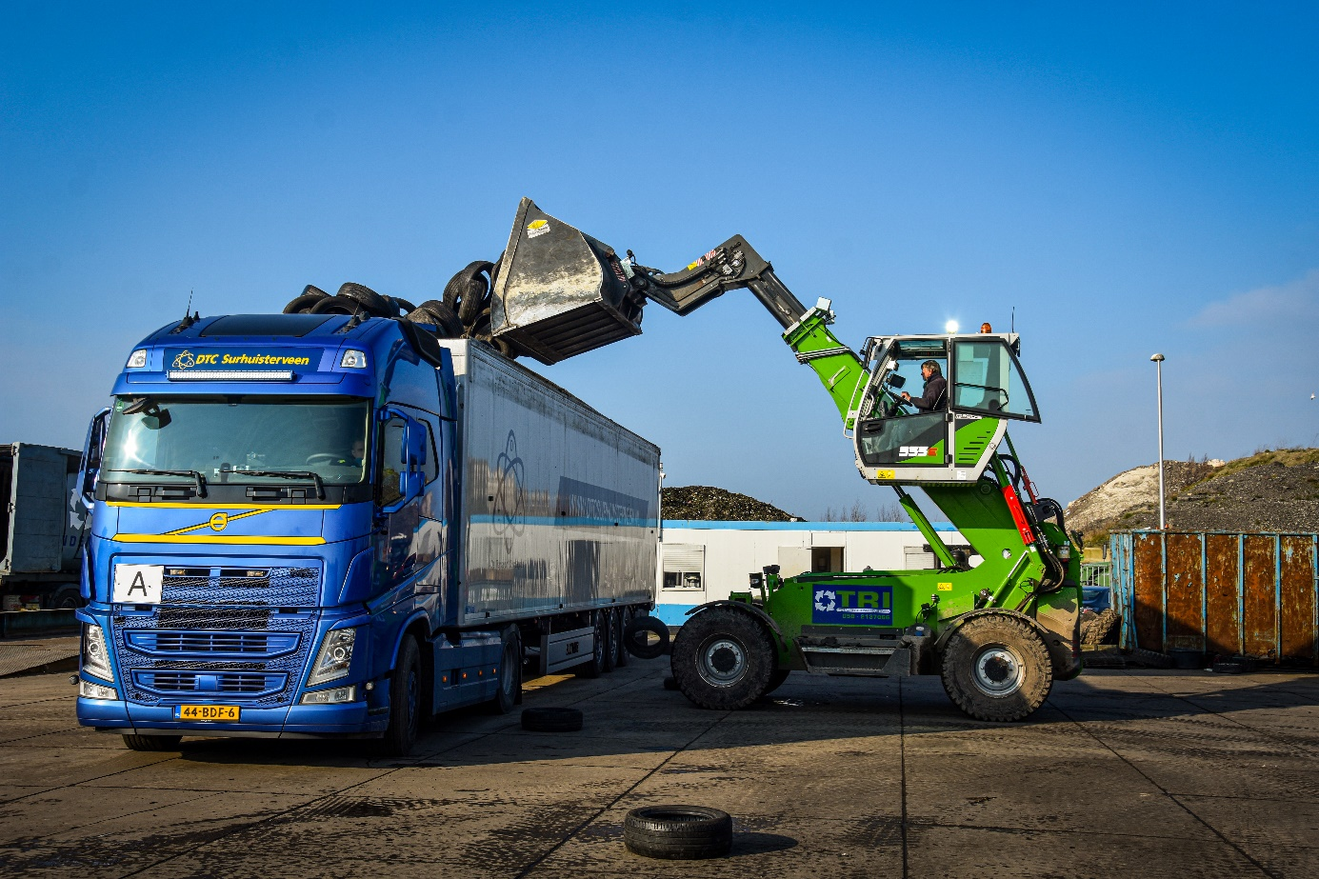
The series standard elevating cab provides operators with a view height of 4.25 m.

