Bild:
Location Ort: Enns (AT)
Photo Foto: German Popp/ Kerstin Wabner
Editor Autor: Kerstin Wabner
Date Datum: 24.09.2020

The finest workplace in the port - Danubia Speicherei in Austria relies on SENNEBOGEN’s port handling giant 895

A project with impact – this is what the "big green one" built for Danubia Speicherei Ges.m.b.H in Enns, Austria, truly is. Together with SENNEBOGEN sales and service partner Ascendum Baumaschinen GmbH, the port specialists successfully completed the major project, the assembly and commissioning of the world's largest material handler.

Leaving the nearby main road opens up a unique view across the port area in Enns, Austria: with 3.5 million m² and around 2,500 m of quay, the Danube port is one of the most important inland ports in Central Europe. And since the middle of 2020, thanks to the investment by Danubia Speicherei Ges.m.b.H., the scenery gained a new outstanding landmark.

BIG and prestigious - SENNEBOGEN 895 at the port of Enns
With the SENNEBOGEN 895 E series, state-of-the-art material handling technology has made its way to Danubia Speicherei Ges.m.b.H: "We were looking for the perfect solution for our business, without having to make any compromises. At bauma 2019, the decision was made," explains Georg Dobesberger, Managing Director of Danubia Speicherei, about the chronological development of the project. The previous solution with two rope-driven harbor cranes was already out of date at that time, the supply of spare parts was becoming more and more expensive due to their age, and the handling volume at their quay was continuously increasing. Today, a volume of around 950,000 tons of material of all kinds, from grain and fertilizers to salt and general cargo, is being handled on the company's quay each year. What is special, however, is that the quay walls are rather high, depending on the water level – and only the 895 with its enormous dimensions was able to meet all of Danubia Speicherei's requirements in terms of range, depth and speed. Together with Ascendum Baumaschinen in Austria the considerations were put into practice: A rail gantry adapted to the gauge width of the existing rails, a reach of 35 m, a port cab that can be elevated and lowered by 7 m, a well thought-out access concept as well as a power supply over 300 m travel distance.
Think BIG and act visionary
Georg Dobesberger knows that with the increased demands of the market, it is necessary to rely on modern technologies: "With the electric motor of the port giant, on the one hand, we are using a drive option that is both resource and environmentally friendly. On the other hand, due to the lower electricity prices, this also makes sense from a financial point of view". The 895 E series works efficiently in two ways: Maximum energy savings can be achieved by combining an electric motor with the latest recuperation technology. SENNEBOGEN's Green Hybrid system is unique on the market because it operates with virtually no reduction in performance along the entire cylinder path: Due to the large system volume of the two hydraulic cylinders on the boom in combination with the nitrogen and piston accumulators next to the boom pivot point, the force remains constant and compensates for the mass of the 54 t boom. Like a spring, energy is stored by lowering the boom and compressing gas. The system then uses this energy to support the next lifting task, which is similar to releasing the spring. This minimizes the amount of force required for lifting and reduces energy consumption by up to 55%.

Versatile, user-friendly workplace with a view
Big machines can cope with even bigger tasks, which is true for the 895 E series, as the machine is specialized in many different areas while remaining extremely scalable. Be it general cargo or various bulk materials, everything can be handled at Danubia Speicherei at ease: Therefore, the port specialists integrated a quick-change system on the stick with various grab applications in order to flexibly switch between handling heavy and light bulk materials as well as general cargo. "The greatest flexibility, however, results from the fact that we can unload ships along the entire quay," Georg Dobesberger continues. For this purpose, a special power supply was installed on the rail gantry via a motorized cable reel, which allows the electric material handler to move easily and conveniently along a total distance of 300 m.

A well thought-out system of stairs and platforms makes it easy to reach the Portcab, a large-capacity cab specially developed for the needs of ports, from which the operators can unload ships, load trucks and trains from a bird's eye view. "Every day I receive feedback from my operators that the 895's cab is the finest workplace in the entire port," Dobesberger concludes with a smile.

[Caption:]
Think BIG: Material handler SENNEBOGEN 895 E series at Danubia Speicherei is the new landmark of the port in Enns (Austria)
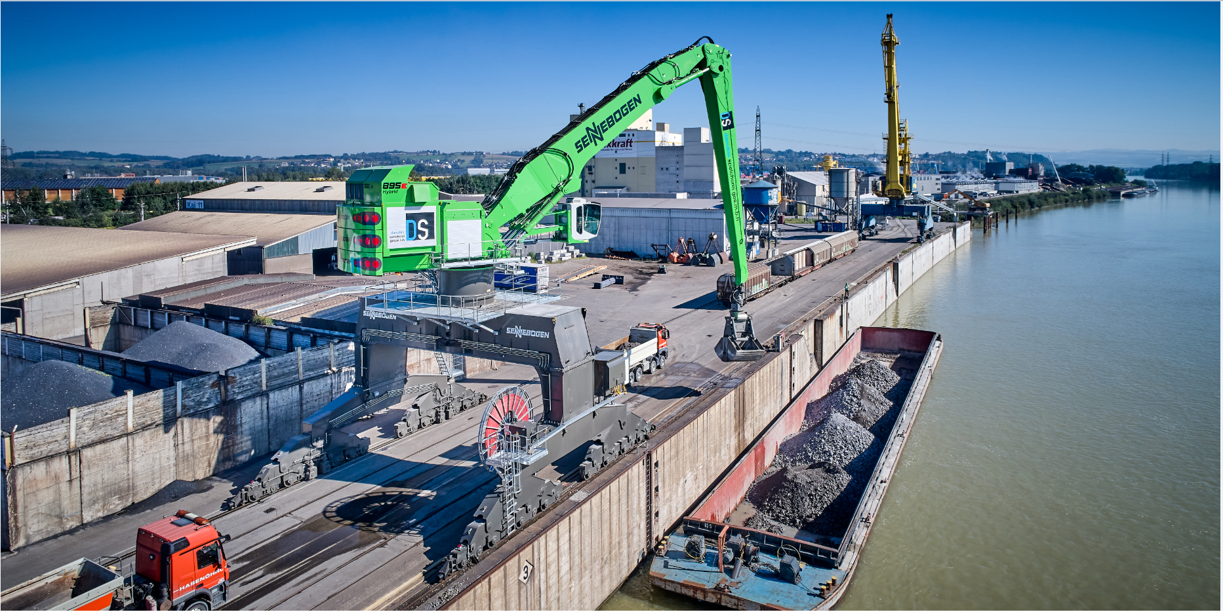 Georg Dobesberger (Managing Director, Danubia Speicherei Ges.m.b.H) is pleased with the impact of the material handler 895 E series 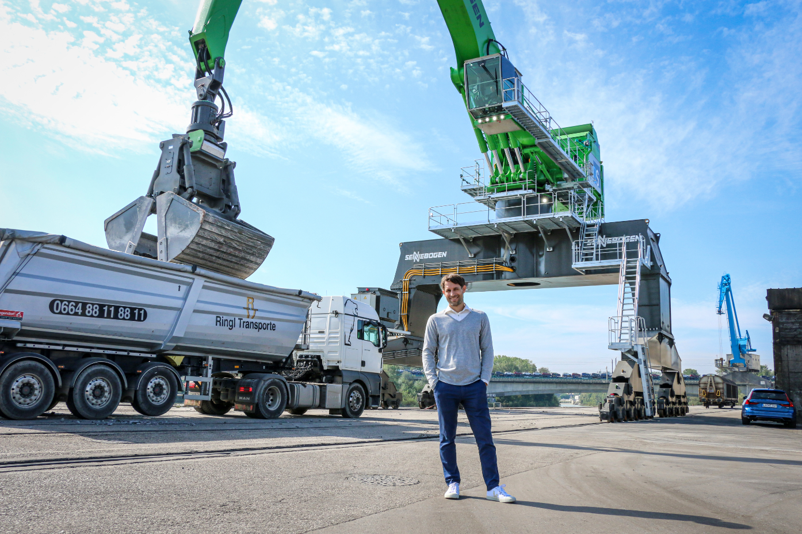
Customized machine design: Use of the existing track width, development of a safe access concept, loading of trucks and wagons simultaneously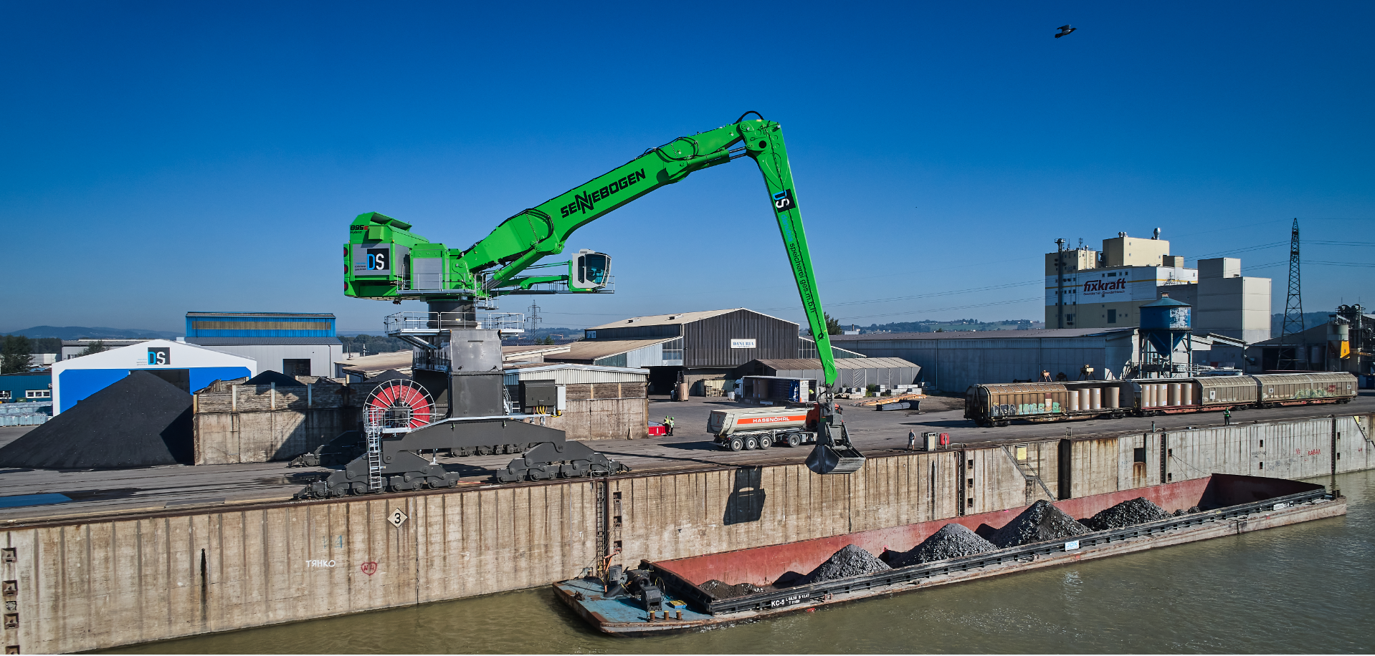
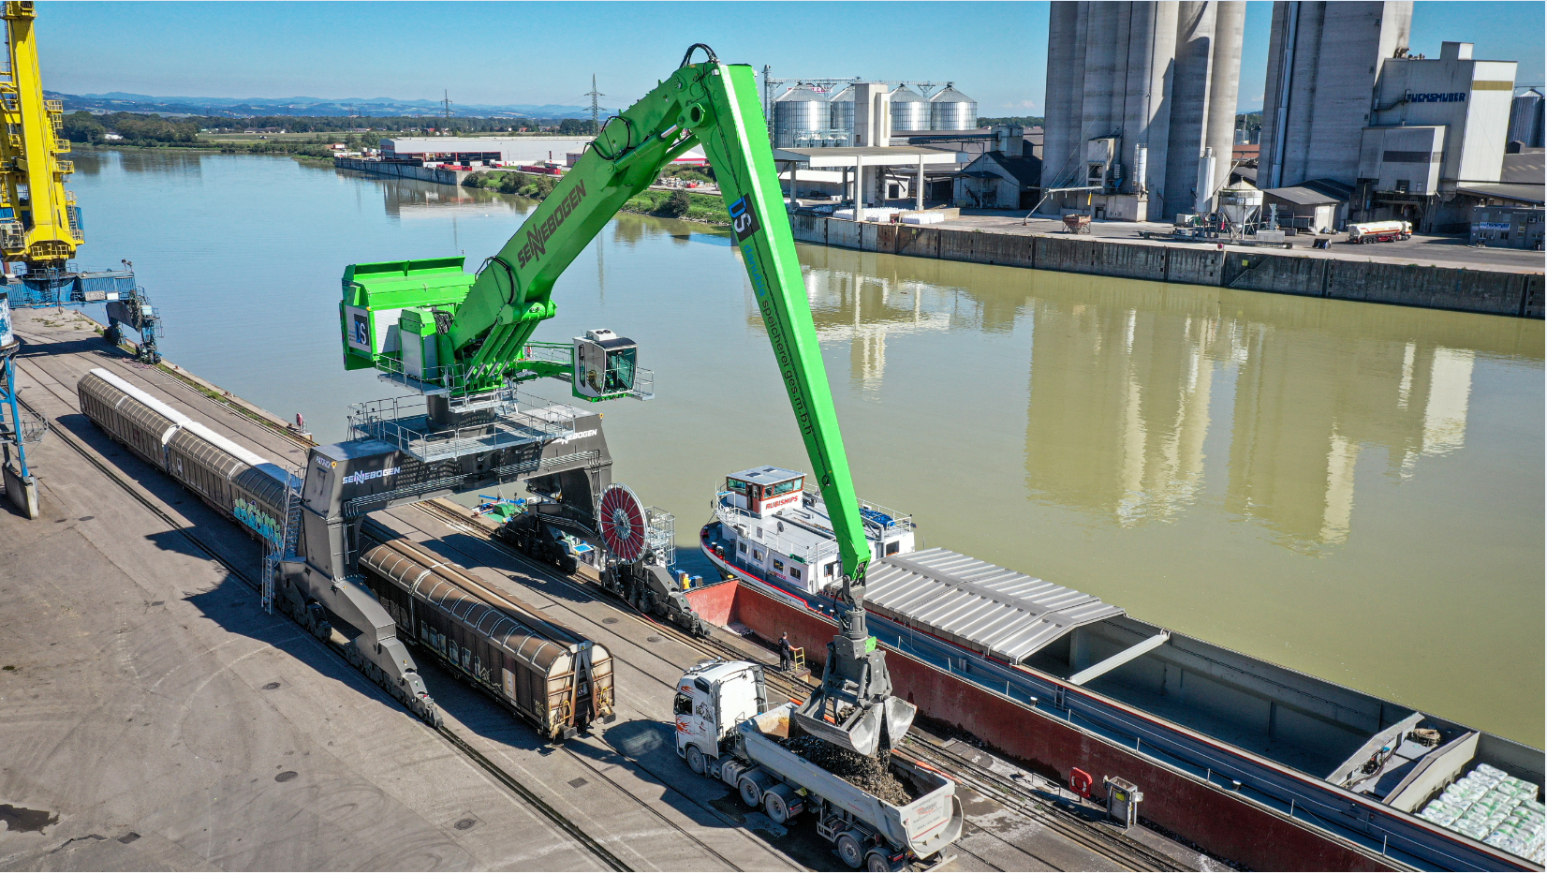

Operator Peter Streimelweger is convinced that he has the finest workplace in the port of Enns