Bild:
Date Datum: April 2021
Location: Sauerland, DE
Photo Foto: Wolfgang Kröll
Editor Autor: Sandra Hartl

Landscape management with tree care handler along country roads and highways
For its tenth anniversary, Hauschulte-Oberdick has given itself a very special present: a new highlight in the SENNEBOGEN product line, the 728 E tree care handler, has now found its place in the company's fleet. As the world's first customer, the tree care company had the opportunity to extensively test the machine and is now enjoying the new machine addition.
The traditional company has been a loyal SENNEBOGEN customer since 2021 supported by sales and service partner BRR Baumaschinen Rhein-Ruhr. An 821 E material handler equipped with a CS 580 woodcracker and a 718 E for grove and landscape maintenance are already a permanent fixture at the company, which takes on supraregional orders in the german Sauerland region. The most important areas of operation for the 30-strong company include landscape maintenance, fuel wood harvesting and felling of hazardous trees. The brand new 728 E tree care handler, which was specially designed for demanding tree care operations, is now the ideal addition to the company's fleet.
SENNEBOGEN 728 E scores with impressive reach and height of over 21 m
With a reach of over 20 m including the attached felling grab saw VOSCH 1600-7T, the newcomer facilitates the challenging tree felling work along country roads and highways. The occupational safety factor in particular plays a decisive role here. The 728 E enables controlled grabbing, sawing and depositing of the logs to the side and, in comparison to traditional arborists, represents a safe alternative, especially for safety felling. The stable mobile undercarriage with wide single tires and 4-point outriggers, on which the support feet can be individually controlled, ensures sufficient stability. In addition, the tree care handler is equipped with a bulletproof cab front screen and a FOPS roof guard.

Flexibility in use decisive for successful tree care work
It is not only occupational safety that is the focus of tree care companies, but also flexibility in use. Due to the optional road approval, the 728 E can move flexibly on site. In addition, a wide variety of attachments, such as harvesters, felling headers or grab saws, can be fitted, making the tree care handler suitable for a wide range of applications. An additional package for the hydraulics, consisting of an additional hydraulic valve and the additional piping, ensures high performance of the 129 kW machine.
Comfort and performance inspire the operator
A machine operator spends quite a few hours a day at work. It is all the more pleasing when he can enjoy a comfortable workplace. Operator Michael Porsch was therefore immediately enthusiastic about his new machine: "We are proud to be the first company to have a 728 E in operation. The performance and the extraordinarily wide reach have convinced us." He can now do his work comfortably in a convenient SENNEBOGEN Maxcab including an air-suspended comfort seat and seat heating. The cab, which can be raised hydraulically by up to 2.70 m and also tilted by 30°, provides the best overview for the operator. At the customer's request, a steering wheel was installed in addition to the joystick steering so that the tree care handler can also be steered easily on roads.

[Caption:]

World's first SENNEBOGEN 728 E with VOSCH grapple saw in tree care operation in Germany
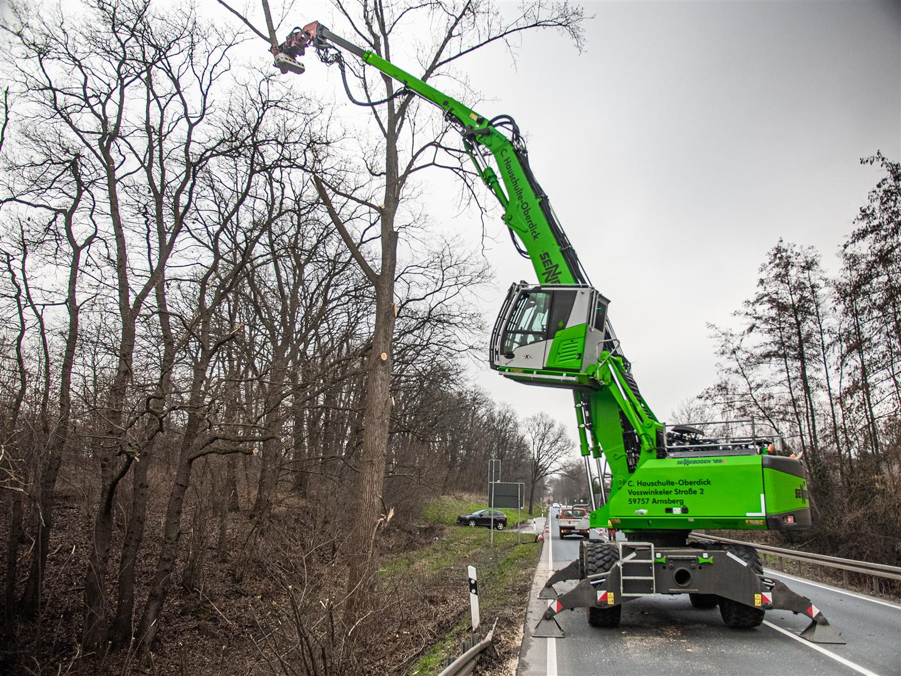

Powerful hydraulics and high flexibility: the 728 E in tree care work on main roads 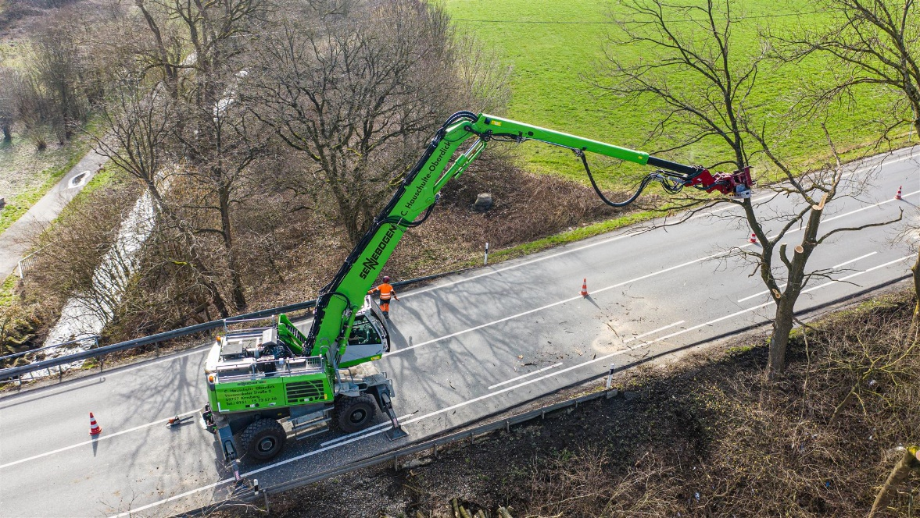

Hauschulte-Oberdick relies on "green" power: a 718 E together with the world novelty SENNEBOGEN 728 E
