Bild:
Photo Foto: Patrick Reinig
Location Ort: Feldkirchen, DE
Editor Autor: Franziska Brielbeck
Date Datum: Mrz-22
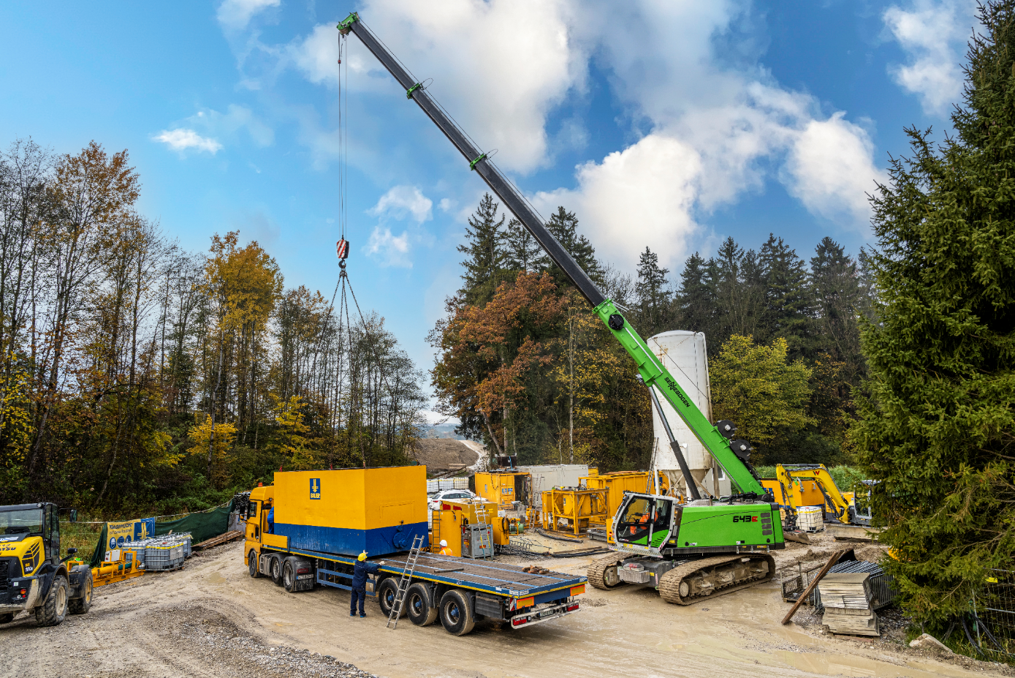

Perfect temporary helper: Construction site dismantling with 40 t telescopic crawler crane
Support is most valuable when you need it – this is especially true on construction sites. When a partially reinforced cut-off wall had to be constructed for a flood retention basin in Feldkirchen near Munich, it was therefore the most effective way for the contracted company BAUER Spezialtiefbau GmbH to simply hire the appropriate crane for the lifting work involved. Since the parts to be lifted had an individual weight of up to 15 t, they chose the 643 E telescopic crawler crane from SENNEBOGEN for the project. Over a period of approximately 3.5 months, the 40 t telescopic crane, provided by the local SENNEBOGEN dealer Fischer und Schweiger, was first used as a supply carrier for the duty cycle crane with diaphragm wall grab and finally also for the dismantling of the construction site - all in all, the perfect helper at the right time.

More jobsite pictures:

