Bild:
Location: Olsberg, DE
Photo Foto: Sandra Hartl
Editor Autor: Sandra Hartl
Date Datum: 11/2022

Fuel savings in the sawmill: Two 735 E with electric traction drive in operation

Up to 30% of fuel consumption can be reduced with the use of the new 735 E with electric travel drive. Pieper Holz from Olsberg in the Sauerland region has decided to supplement the already successfully used log handling machines from SENNEBOGEN with two diesel-electric 735 E Green Efficiency Drive.

Pieper Holz can already look back on more than 70 years of experience in wood fabrication. Founded by Georg Pieper and now managed by the third generation, the company is an expert in sawn products for construction timber and packaging, pellets as well as garden timber, garden furniture and playground equipment for the public sector from its own production. Since 2012, Pieper has relied on SENNEBOGEN Pick and Carry machines. On a permanent basis, three diesel-powered 735 E machines handle log transport at the plant, feed to the plant, and pick at the sorting lines. The first diesel-electric Pick & Carry machine has been in operation since spring 2022. This was followed in October by the official handover of the second 735 E GED at bauma.

Electrification of timber handling machines as part of the sustainability strategy
Pieper Holz has long been concerned with the issue of sustainability and the energy-efficient expansion of the plant. An energy team set up specifically for this purpose takes care of fleet improvements, among other things. The interest in electrifying material handlers has therefore existed for a long time. "Environmentally friendly production is very important to us," says Dirk Steinhausen, head of technical maintenance at Pieper Holz. "Our raw materials are processed sustainably, and so we also try to design our vehicle fleet with sustainability in mind." For Pieper Holz, a switch from diesel-powered handling machines to a hybrid system of electric and diesel machines is an ideal addition to the company's sustainability strategy.

Green Efficiency Drive: energy savings of up to 30 percent
In order to save fuel, two electric traction motors are installed in the electric version of the 735 E. The energy for the electric travel drive is generated by a generator mounted on the diesel engine. This means that the timber material handlers remain mobile and are not dependent on a cable power supply. The combination of the electric drive installed in the undercarriage with the intelligent energy management system reduces energy consumption by up to 30%. The first 735 E GED in the fleet has been in operation for over 7 months and around 1,900 operating hours and has successfully demonstrated the energy savings: Diesel consumption in trailer operation fell by exactly 30 % after evaluation. The driver can operate his machine for up to 31 hours without refueling.

Driving dynamics are particularly evident on inclines - even when towing a trailer
It was particularly important for Pieper Holz that the diesel-electric machines also prove themselves on slopes. There are two slopes at the plant site with gradients of up to 12.5% that have to be overcome by the excavators several times a day. "I am amazed every time at the ease with which the 735 E GED manages the considerable incline," says Andreas Nölke, driver at Pieper Holz. "In general, you don't notice any difference in trailer operation. The driving dynamics of the GED are really impressive." The new timber handlers run 95% of the time in trailer mode and are mainly used for longer trips on the site. Attached are 3 m² timber grabs, so four grapple loads can be transported per trip.

Driver comfort at the highest level: GED impresses with smooth running
The electric drive reduces vibrations and noise in the cab, allowing fatigue- and stress-free work. "The issue of noise was also important to us, as our plant is directly adjacent to a residential area. By using the new Pick and Carry machines, we can optimize the noise level for the residents," explains Dirk Steinhausen. Together with SENNEBOGEN sales and service partner Schlüter für Baumaschinen GmbH, they found the ideal solution for energy-efficient timber handling at Pieper Holz.

[Caption:]

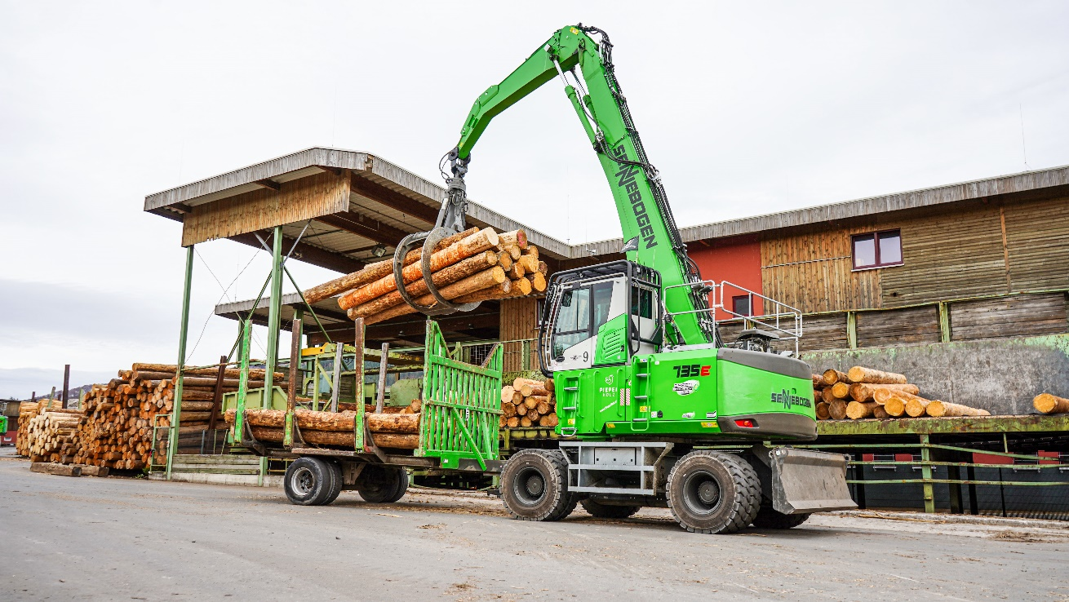
Electrified timber handlers run mostly in trailer mode and are used for longer distances in the plant
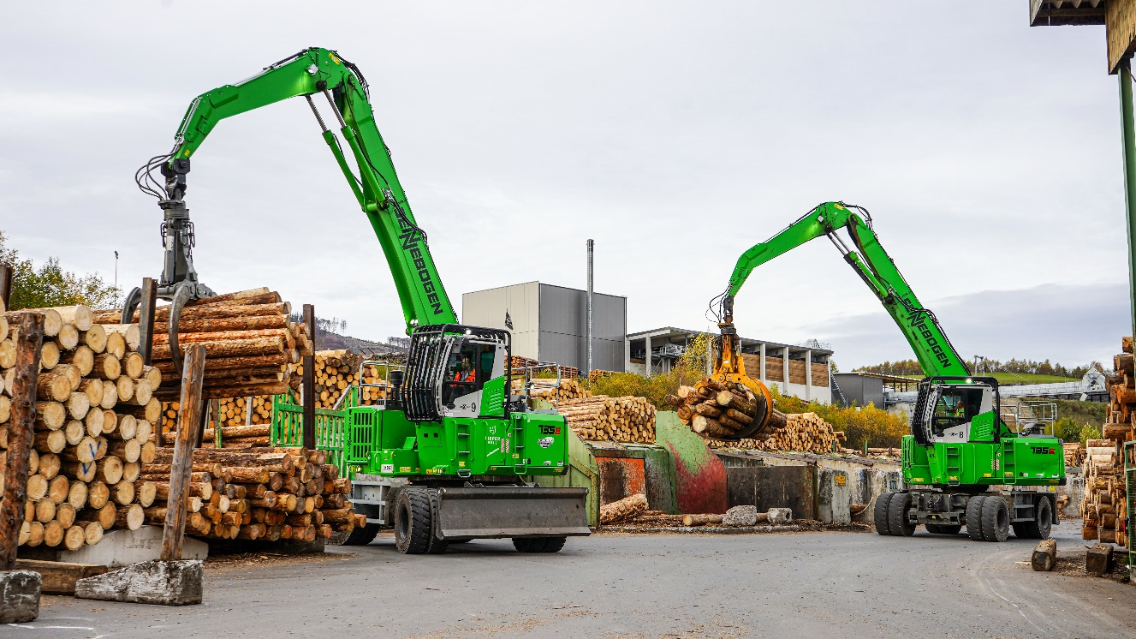
735 E GED and 735 E work in parallel on the sorting line and take over the log transport in the sawmill
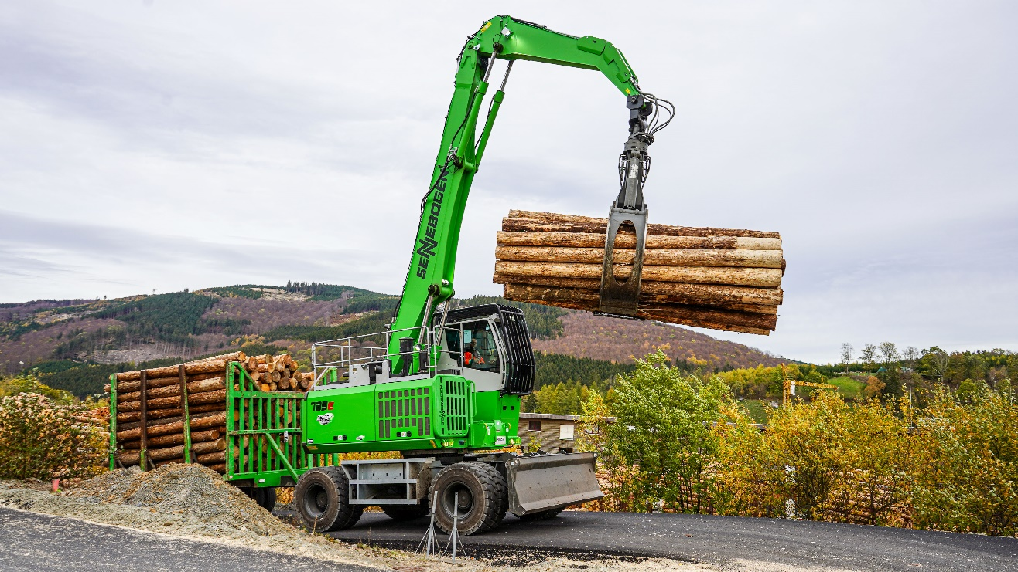
Even on a 12.5% incline, the 735 E GED delivers outstanding performance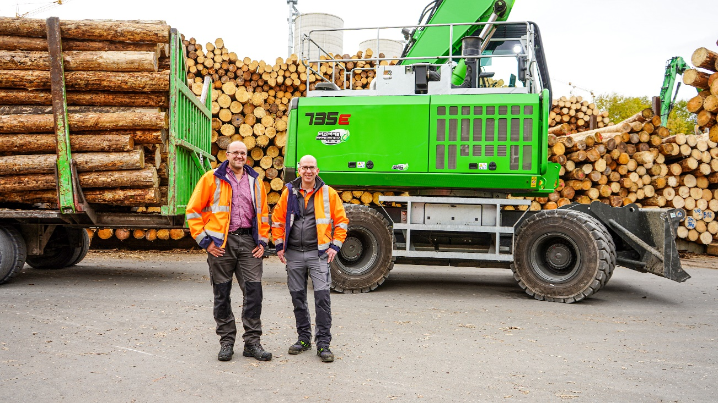
Machine operator Andreas Nölke (left) and head of technical maintenance (right) are very satisfied with the new Pick & Carry machines in the fleet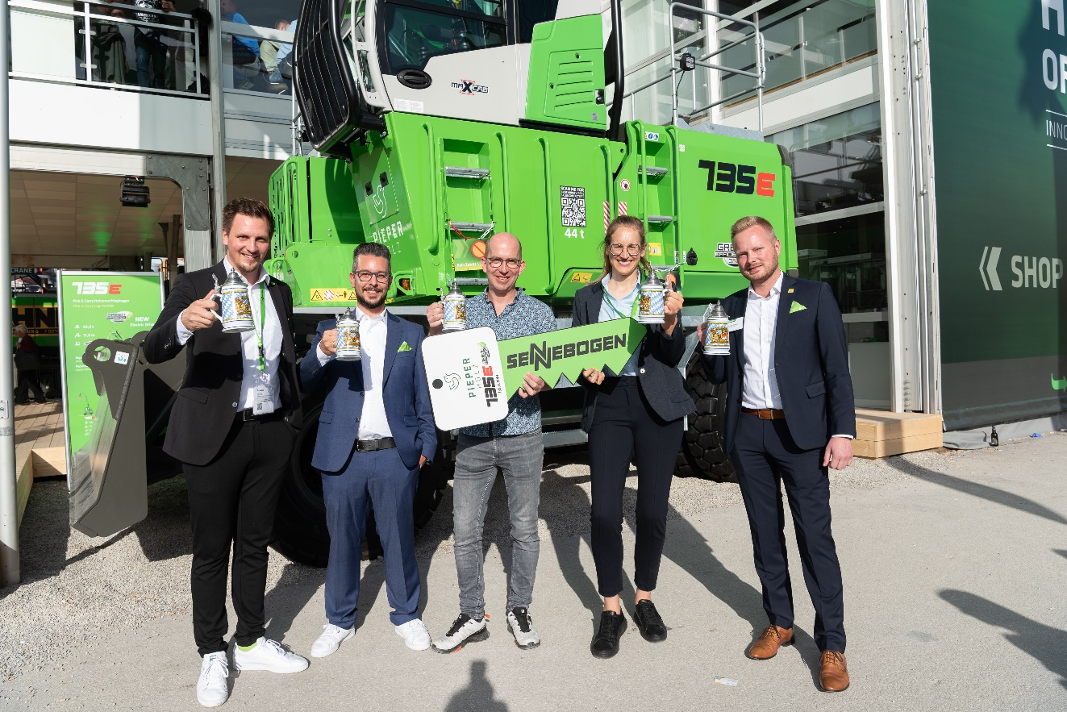
Machine operator Andreas Nölke (left) and head of technical maintenance (right) are very satisfied with the new material handlers in the fleet

