Editor Autor: Jason Ang & Benjamin Burkhardt
Location Ort: Japan
Photo Foto: Sun Earth
Date Datum: 13.10.2021

Material handler instead of excavator in metal recycling: greater performance, efficiency and safety for metal recycler in Japan

When Iwamoto Metal Co Ltd's earthmoving excavator, which had been converted for material handling, needed to be replaced, it was clear that the new machine had to be more powerful and at the same time incur lower operating costs. The new material handler is custom-built and perfectly adapted to the material handling conditions on site: a SENNEBOGEN 830 E with 4.5 m pylon and 132 kW electric drive.

Iwamoto Metal Co Ltd is a BIG PLAYER in Japan in terms of metal recycling. More than 90,000 tons of scrap metal are processed per month at 11 scrap yards spread throughout the country. The trend is on the rise, as the recycling expert is seeing an increasing influx of scrap particularly from the automotive industry.

Modern material handler replaces modified earthmoving excavator in metal recycling
The higher influx of scrap means that the machines are subjected to higher loads, have to process more material in the same time, and the space on site has to be used more effectively. The new acquisition is to play a key role at the site, loading the metal scrap delivered by trucks and feeding the 7 m high shredder. This made the decision all the easier for the company to replace the previously used, converted earthmoving excavator with a machine that is specially designed for material handling in recycling and perfectly adapted to the material handling conditions at Eichigawa. Like a tailor-made suit that fits perfectly and is ready for any situation.

What are the differences between an earthmoving excavator and a material handler? "Earthmoving excavators often reach their limits in recycling and scrap handling in terms of load capacity, engine power and cooling," explains Takeshi Iwanami, product expert at SENNEBOGEN's Japanese sales and service partner Sun Earth Co. Ltd.
Conditions in earthmoving differ from those in material handling: earthmoving excavators are designed to exert their force downwards, directly into the soil. Material handlers are optimized for high reach heights with maximum payloads. In these areas, earthmoving excavators lack the necessary power. The material handled also has a crucial difference. Earth material has a much lower density than scrap aluminum, copper or steel, for example. Since less load capacity is required, the engines of earthmoving excavators are generally smaller in size. The consequence: there is a lack of power and also the appropriate engine cooling to be able to work reliably and sustainably in material handling. If those tasks are carried out with a material handler, the operator can look forward to high engine and hydraulic power. This is the only way to move heavy material safely and efficiently.

Increased performance through customized configuration and electric drive
In addition to these advantages, the material handler from Iwamoto Metal Co Ltd. shows: the more a machine is adapted to the customer's needs, the higher its efficiency. In order to contribute to environmental protection and reduce operating costs, the scrap recycler deliberately chose a material handler with 132 kW electric drive. The 4.5 m pylon elevation provides the best possible view of the scrap piles up to the 7 m high shredder. Thanks to the liftable cab, operator Hisao Sugino can see over even the most remote corners with a maximum eye level of 10 m. This increases efficiency and, above all, reduces the risk of accidents.

A much better view, noticeably more power and precise control: operator Hisao Sugino is more than satisfied with the new machine. For years, his employer has relied on the green machines "Made in Germany" at all its sites and on the cooperation with SENNEBOGEN sales and service partner Sun Earth Co. Ltd. "We are glad that we decided for the electric material handler. The machine performs much better than its predecessor and the operating costs are much lower," emphasizes Hiroshi Iwamoto, Managing Director of Iwamoto Metal Co Ltd.
Bildunterschrift:
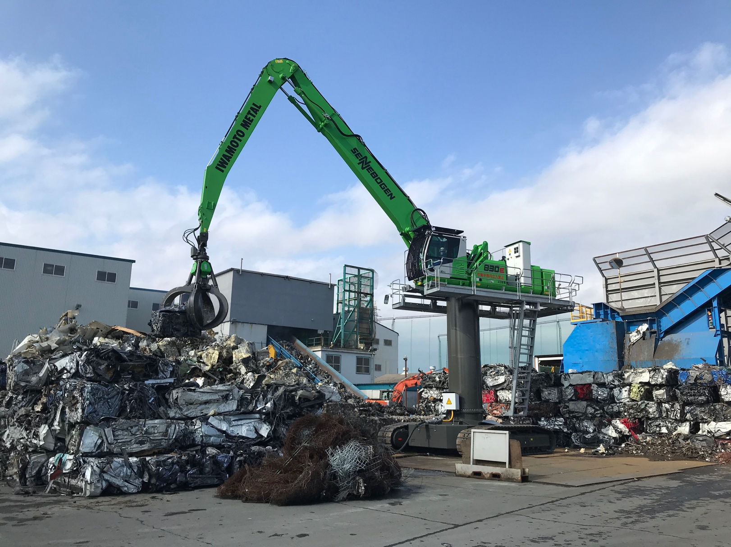
- Material handler instead of earthmoving excavator in metal recycling: with crawler undercarriage, 4.5 m pylon and 132 kW electric motor, the machine is precisely configured for the material handling conditions of Iwamoto Metal Co Ltd's largest plant.

- Maximum working comfort in recycling for operator Hisao Sugino thanks to comfort seat, air conditioning, ergonomic joysticks and a cab that can be raised by 2.7 m.
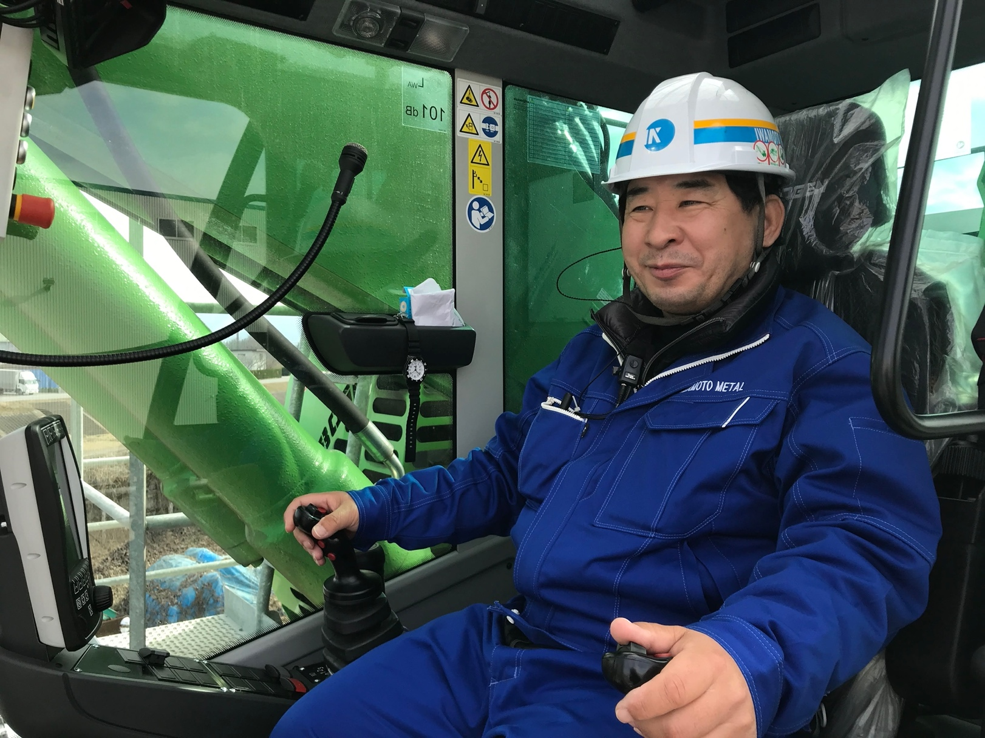

- The 4.5 m pylon and the 2.7 m cab elevation provide ideal visibility into the 7 m high shredder and truck trailers.
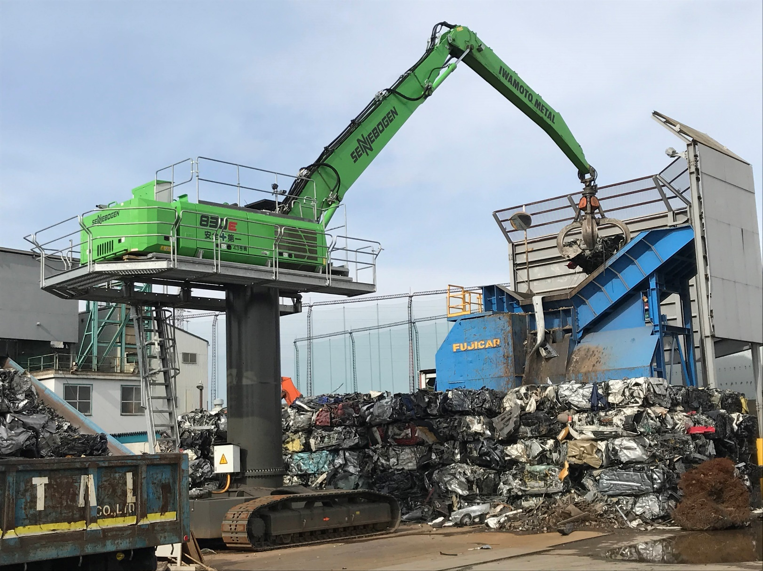

- Official machine handover to a loyal SENNEBOGEN customer - from left: Yutaka Ebihara, (President of Sun Earth Co Ltd), Hiroshi Iwamoto (Managing Director and owner of Iwamoto Metal Co Ltd), Walter Sennebogen (Managing Director and owner of SENNEBOGEN), Anton Sennebogen (Head of Corporate Controlling at SENNEBOGEN) and Marco Burgmer (Managing Director of SENNEBOGEN Asia Pacific)