Bild:
Location Ort: Brescia, Italy
Photo Foto: Cesaro Mac Import
Editor Autor: Cesaro Mac Import / Kerstin Gruber
Date Datum: 29.1 1.2021

Steel logistics with SENNEBOGEN 865 E Hybrid at Italian logistics and transport service provider Trailer S.p.A.

The steel handling at the railroad terminal of Trailer S.p.A. should be simpler and more effective in the future: during the renewal of the logistics processes on site, the new 865 E Hybrid from SENNEBOGEN came into play. With support from the sales and service partner Cesaro Mac Import, the Italian company now relies on a material handler with a magnetic lifting beam that can easily handle steel items weighing around seven tonnes.

As early as 1953, the success story of the traditional company Trailer S.p.A. began in the city of Brescia in northern Italy: What once started with freight transports and a single, retired US military transport truck has today grown into a modern logistics service provider with a large fleet of vehicles, specializing in the intermodal transport of steel products.

About a year ago, Trailer S.p.A. started operations in a railroad terminal with five tracks. The machines still in place, some aging crawler cranes and heavy-duty forklifts, urgently needed to be replaced as the processes on site no longer performed quickly and safely enough. Together with SENNEBOGEN sales and service partner Cesaro Mac Import, the company found the perfect solution for even more effective and safe handling of semi-finished steel products.

865 E Hybrid saves a lot of time in steel handling and in the logistics process
This is why the company has chosen SENNEBOGEN's new 90-tonne model, the 865 E Hybrid. Created for heavy duty port applications as well as for steel handling, the 865 E at Trailer S.p.A. operates with an 18 m equipment in combination with a magnetic lifting beam. With the powerful lifting device, the 865 E moves steel products, such as steel beams or wire rods, weighing around seven tonnes. In the past, the steel products needed to be secured in a complicated procedure by chains and belts when being lifted by a crane, but from now on the magnet completely eliminates the need to secure the load during the handling process. This saves a massive amount of manpower and time, and also makes the daily work routine substantially safer for the operators.

Another highlight is the integrated scale, which allows the operator to check the weight of the handled goods. Directly in the cab, the operator receives instructions from the control center on how the freight should be arranged to be loaded onto trucks or wagons. And thanks to the integration of the scale into Trailer S.p.A.'s in-house computer systems, the operator receives direct feedback on the correct charging of the transport vehicle. In order to save time, the required transport documents are already prepared in the background and generated in real time.

The 865 E Hybrid not only saves time, but also up to 50% energy
As the name already indicates, SENNEBOGEN installs the proven Green Hybrid recuperation technology in the 865 E Hybrid, which can save up to 50% energy and thus a lot of fuel when used correctly. Hybrid means that in addition to a fuel-saving 261 kW Stage V diesel engine, a second component is installed that significantly supports the engine's performance. Here, a separate hydraulic circuit is used, consisting of a third hydraulic cylinder between the two lift cylinders and piston accumulators in the protected rear area of the machine. When the boom is lowered, the repelled oil compresses gas in the accumulators to store this energy until the next working stroke. Just like a spring that relaxes, the boom moves upward without requiring any further energy, and the engine is completely relieved by the temporarily stored energy during the lifting process.

As simple as the system's operating principle is, the more effective it is in the daily business. Gabriel Hutu, Operations Manager of Trailer S.p.A.'s rail terminal, is also convinced of this and sums up: "For us, this machine is a symbol of the company's modernization. It changes the way we think and work, increases operational safety and reduces the environmental impact of our processes. Thanks to its large lifting capacity, even at maximum reach, we can transfer loads of seven tons on average from a truck to a rail wagon or vice versa - enormously fast and fuel-efficient, too."

As of now, the SENNEBOGEN 865 E Hybrid reliably and safely handles steel products with a magnetic lifting beam at Trailer S.p.A., an Italian transport and logistics service provider.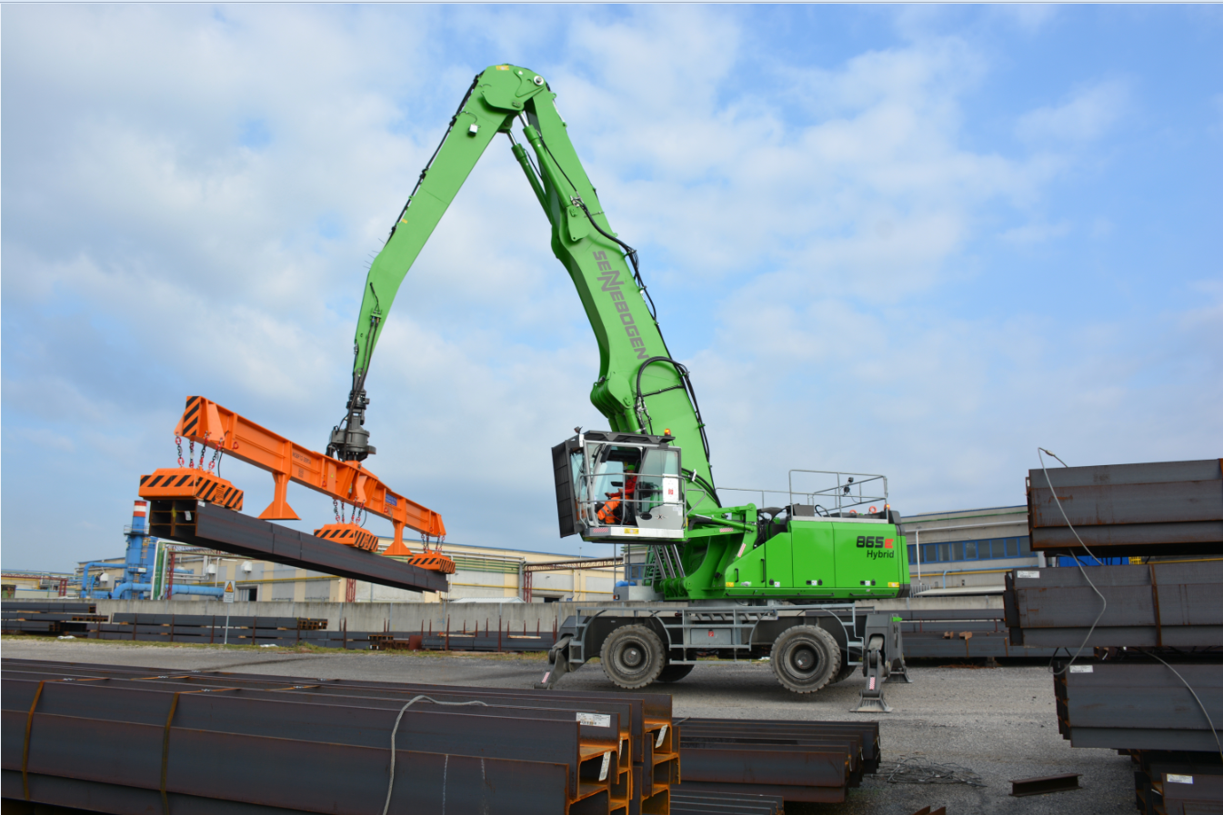
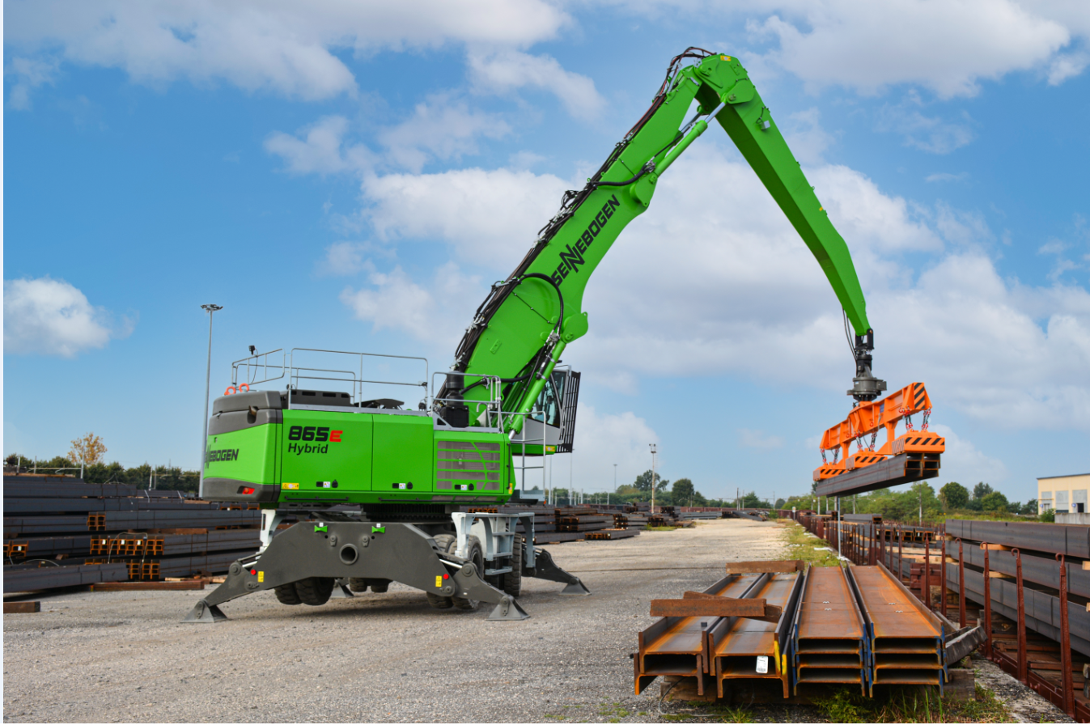

About seven tonnes of load can be lifted with the magnetic lifting beam: trucks and wagons are prepared for onward transport in a time-saving manner and with less manpower required 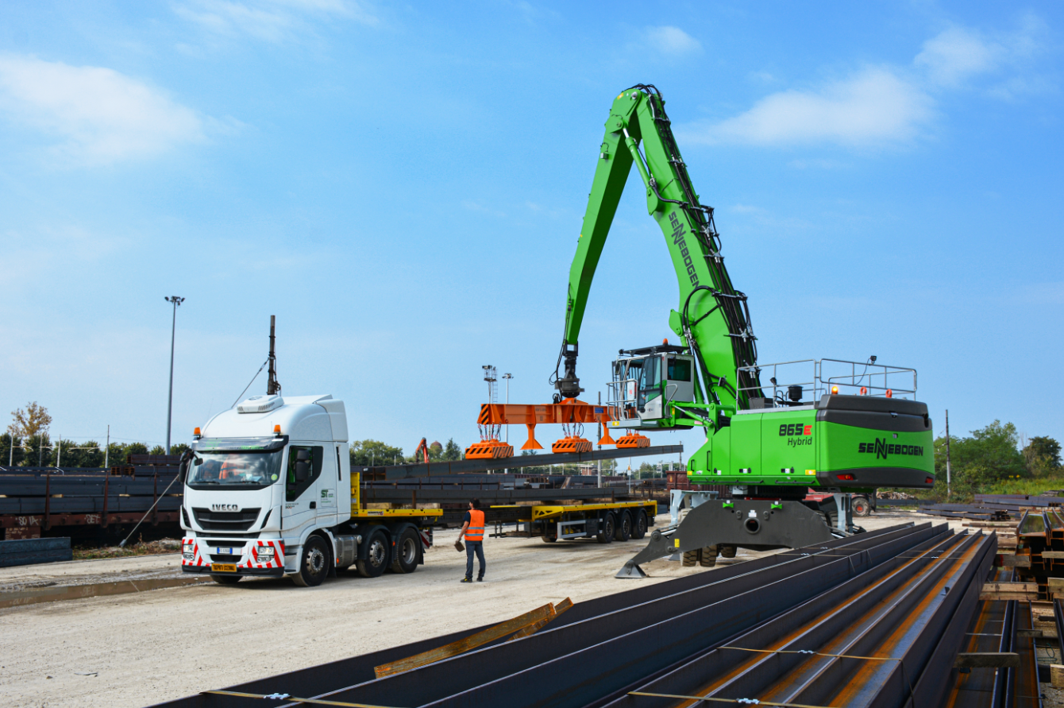
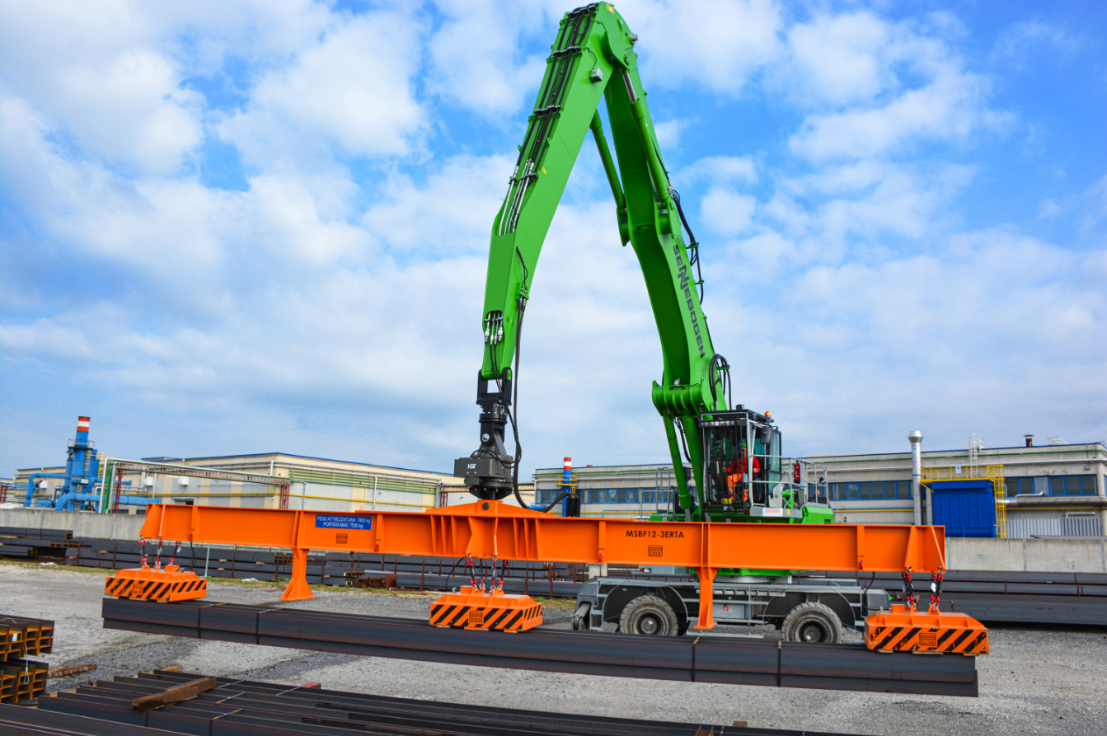
The protective grating as special equipment of the Maxcab Industry cab provides even more safety 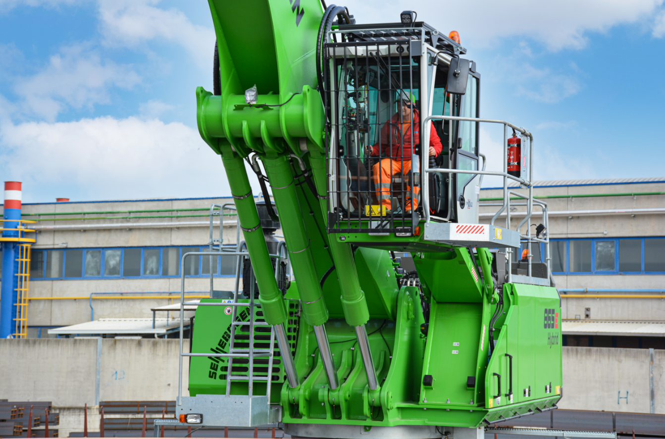
Gabriel Hutu, operations manager of Trailer S.p.A.'s rail terminal, is convinced that the 865 E Hybrid has successfully modernized the company's logistics processes
