Bild:
Editor Autor: Jennifer Bortmes
Location Ort: Lyss, Switzerland

Date Datum: 06.11.2023

Multifunctional disposal concept for the recycling yard

Turning waste into valuable raw materials - that is the mission of edi Entsorgungsdienste AG in Lyss. Since its foundation in 2004, 45 employees ensure that 95 % of the more than 250,000 tonnes of waste delivered each year can be reused. Their holistic disposal concept ranges from collection and transport to the recycling of a wide range of industrial waste such as ferrous scrap, non-ferrous metals, electrical scrap, wood, paper, glass, cables, used tyres and plastics. Between all the containers, shredders and sorting plants, the manoeuvrable 340 G telehandler from SENNEBOGEN is at work and proves to be a true recycling all-rounder. The machine was delivered by the local sales and service partner Kuhn Schweiz.

Multifunctional and powerful machine with maximum manoeuvrability

The SENNEBOGEN 340 G telehandler has a lot to do at the recycling centre: from stacking materials such as wood to loading construction waste and inert materials to crushing and loading glass or feeding systems such as the pulping mill. The latter is used to process electronic scrap. Pre-shredded material is broken up in the grinder, causing the material composites to detach from each other. These are separated into different fractions via several vibrating plates and can then be further processed.

Due to the particularly confined space conditions, the company needed a powerful machine that was compact and agile at the same time. No problem for the 340 G, because with its small turning radius and compact dimensions of a maximum overall height of 2.50 m, manoeuvring on the recycling site is child's play. During operation, the system automatically selects the optimum setting for fast travel, handling an uphill gradient or picking up material.
The telehandler is equipped with various attachments for its wide range of tasks, allowing maximum flexibility when handling different materials. Thanks to the quick coupler, the waste disposal company can switch between a bulk bucket, grab bucket, container hook and lifting fork in a matter of seconds and at the touch of a button.

Best comfort and ideal all-round visibility

In addition to the performance, one point in particular stands out for machine operator Marc Uebelhart: "What do I like best about the machine? Clearly the comfort! You get in and feel like you're at home on the sofa." The cab of the new machine generation offers protection against excessive noise and vibrations. The air-sprung comfort seat and the ergonomically arranged controls also contribute to the pleasant working environment.

The ideal all-round visibility is another major advantage of the telehandler. The cab can be raised to an eye level of 4.10 m, which enables optimal loading of trucks and containers. "There is a lot going on on the site, so a good overview is very important. With the 340 G, we can see much more than with other telehandlers or wheel loaders and can therefore load more and higher. The machine comes in the perfect size," says Marc Uebelhart.

Captions:

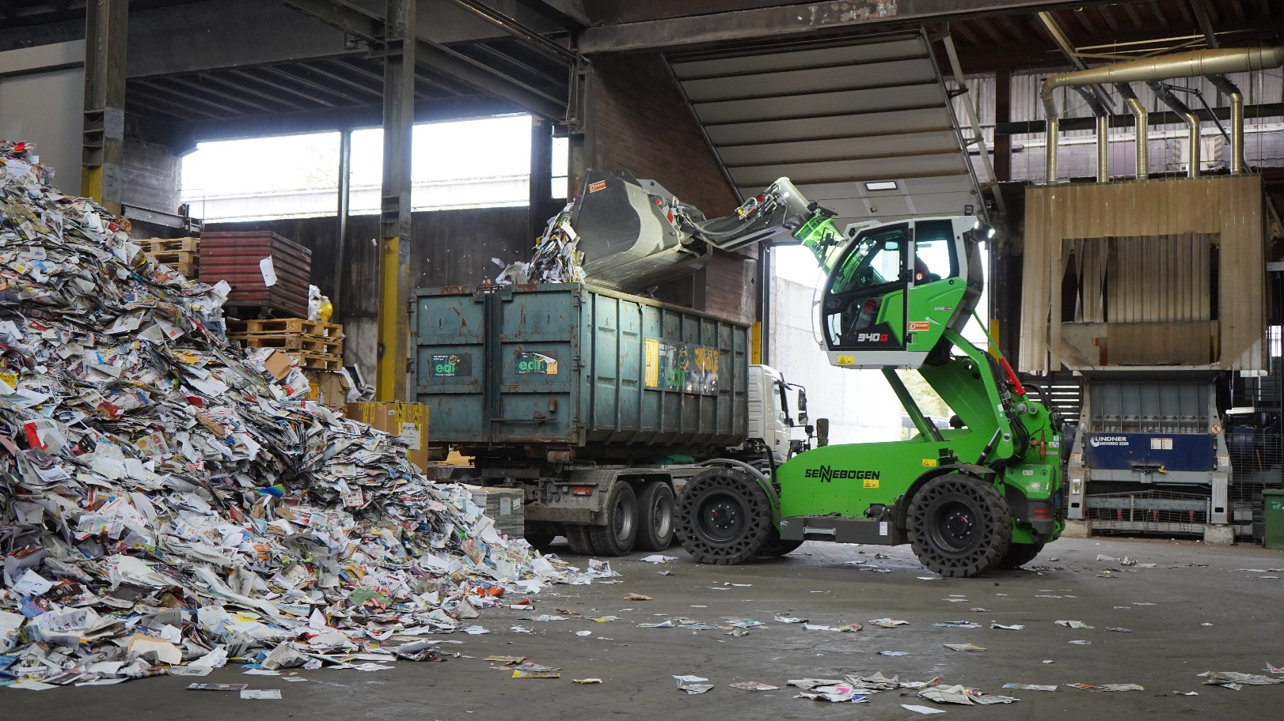
Best visibility when loading trucks thanks to a viewing height of up to 4.10 m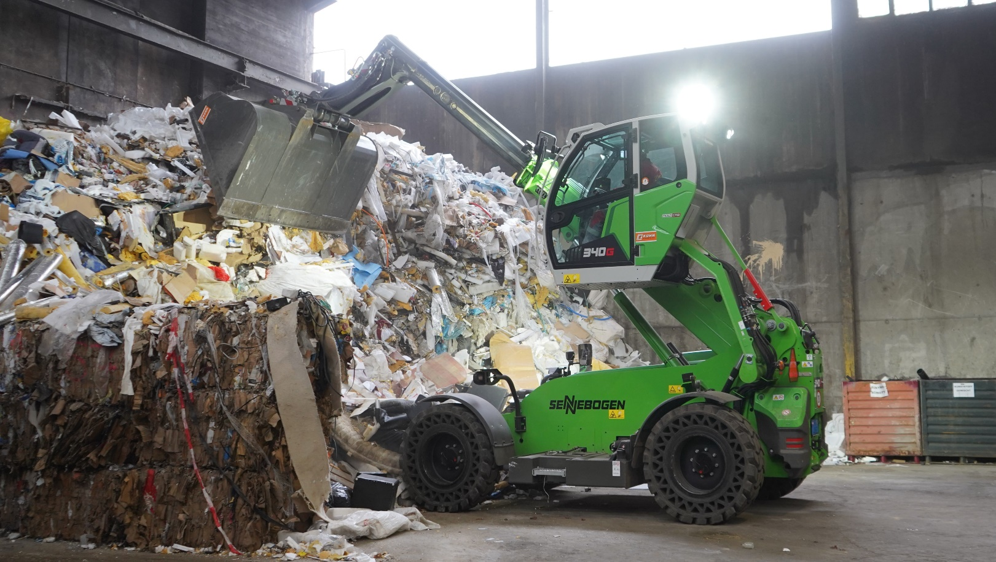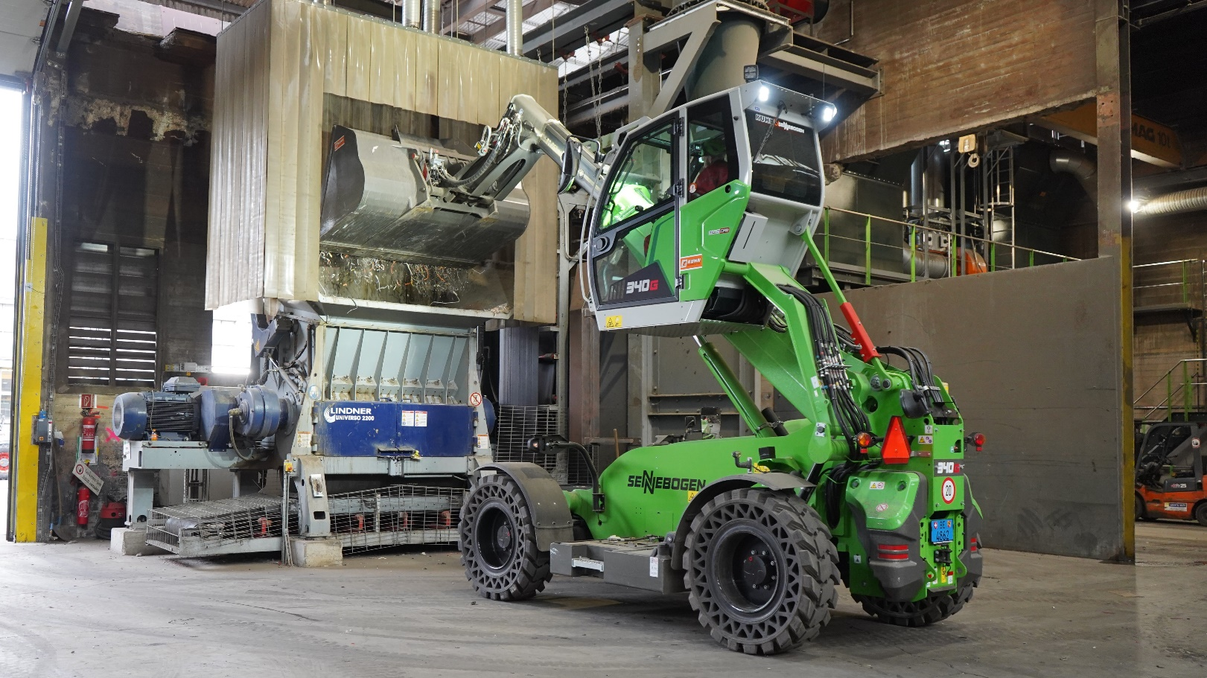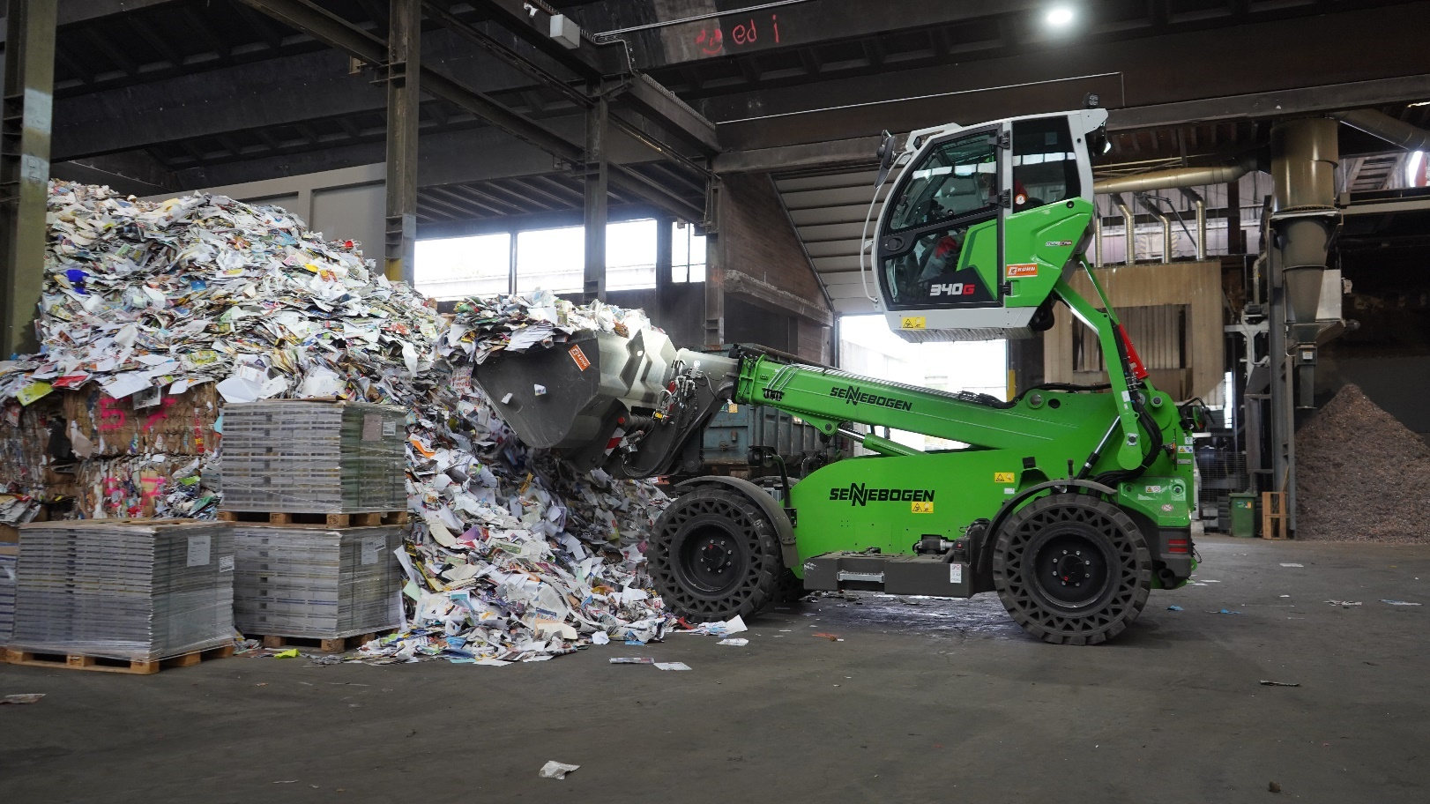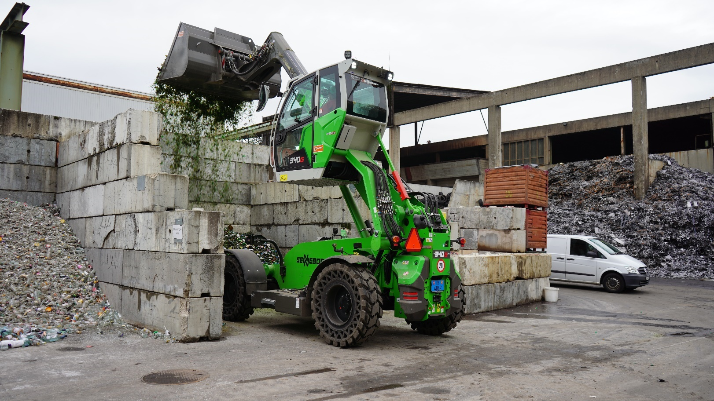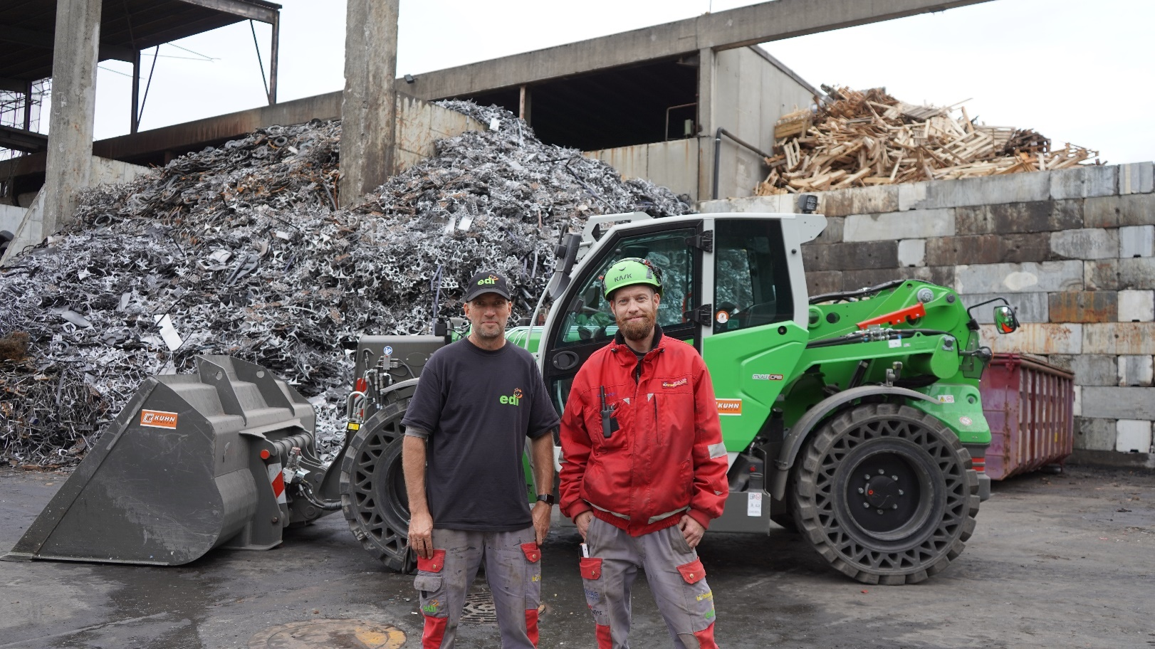
Operations manager Lukas Ledermann and machine operator Marc Uebelhart

