Date Datum: Mrz-23
Location Ort: Straubing, DE
Photo Foto: Franziska Limbrunner
Editor Autor: Franziska Limbrunner
Port construction: Setting marine tie rods with two telescopic crawler cranes

The port basin of Straubing port is being dredged deeper in the course of the current modification of the Danube. As a result, the sheet pile wall of the port quay will also have to be reinforced by additional tiebacks. The contracted specialist in civil engineering Stump-Franki is using two telescopic crawler cranes from SENNEBOGEN for this complex construction project on and off the water: the 33 t crane 633 E, which works on a pontoon, and the 50 t crane 653 E, which performs the work on the quay with rubber pads on the crawler plates that are gentle on the ground.

In order to promote navigation and flood protection on the Lower Bavarian Danube, the depth of the river channel between Straubing and Deggendorf is currently being increased. Since the port of Straubing-Sand is a so-called "shelter port", which is intended to provide ships with a protected anchorage in emergency situations, such as low water, the depth of the port basin must also be adjusted and dredged to a depth of approx. 65 cm. To ensure that the stability of the basin continues to be guaranteed after this extensive modification, the long-established German foundation engineering company Stump-Franki was commissioned to reinforce the port quay sheet pile wall by means of an additional tieback. Within three quarters of a year, therefore, exactly 1076 marine tie rods are to be installed on all three sides of the basin. For this purpose, they used their 33 t telescopic crawler crane from SENNEBOGEN and supplemented it especially for the port project with a 50 tonner, 653E, rented from the SENNEBOGEN Vertriebsgesellschaft and specially equipped for use in the port.

Teamwork in handling the tie rods and debris troughs
As port operations are to continue unhindered during the work, the hydraulic engineering project requires a considerable amount of coordination between the specialist civil engineering company, the port operator, the operating ships and hauliers. In addition, this also means that the cranes, which work hand in hand when handling the marine tie rods and debris troughs, have to be particularly reliable and flexible at the same time. Telescopic crawler cranes, which are known for their high flexibility in operation, prove to be ideal here. Site manager Christoph Müller confirms: "The decision to supplement our own 30-tonner from SENNEBOGEN with a 50 t telescopic crawler crane from the same brand for this project was definitely the right one. The 50-tonner is in no way behind its little brother in terms of reliability, and the cooperation with SENNEBOGEN Vertriebsgesellschaft as the rental company also works excellently. The contact persons are always available with advice and assistance – and, for example, it was also not an issue at all to equip the rented telescopic crawler with screwed-on rubber pads on the crawler plates especially for this application, so that damage to the quay can be ruled out during the many pick and carry trips."

50 t telescopic crawler crane 653 E with rubber pads: Pick & Carry on the quay
The 50 t telescopic crawler crane, which was rented especially for the project, works on the quay and is therefore equipped with rubber pads on the crawler floor plates that are gentle on the ground. On the one hand, it takes care of loading and unloading the low-loaders, which regularly deliver new tie rods and collect the debris troughs filled with the washed-out rock material. On the other hand, it also loads the supply pontoon that travels back and forth between the quay and the work pontoon. For this purpose, it moves in continuous pick-and-carry operation with the debris troughs weighing up to 11 t or with the up to 29.5 m long marine tie rods on a 20° sloping ramp down to the port basin. Crane operator Tommy Gärtner praises above all the combination of robustness and flexibility that the 50-tonner has to offer: "I have driven cranes from different manufacturers before, but I like the SENNEBOGEN best because it convinces me above all with its robust design and simple, sensitive control. Even delicate operations such as moving on the ramp with a spreader beam and the almost 30 m long tie rods on the hook become almost child's play with this machine."

SENNEBOGEN 633E: lifting operations on the pontoon
The compact 33 t telescopic crawler crane is used directly on the working platform. In this particularly confined space situation, it acts as the central lifting device. This means it picks up the tie rods from the supply pontoon, threads them into the drill rig, and also handles the debris troughs. These must meticulously hold all the soil material that is flushed out so that the increased environmental protection conditions that apply to the construction site, which is located directly on the water, are properly met. A total weight of up to 11 tons is therefore not uncommon for the skips.

The special foundation engineers are satisfied. "We are pleased that we are making such good and rapid progress with the job, and nothing stands in the way of completion on target. The reliability of the cranes certainly also makes its contribution here," Müller confirms in conclusion.

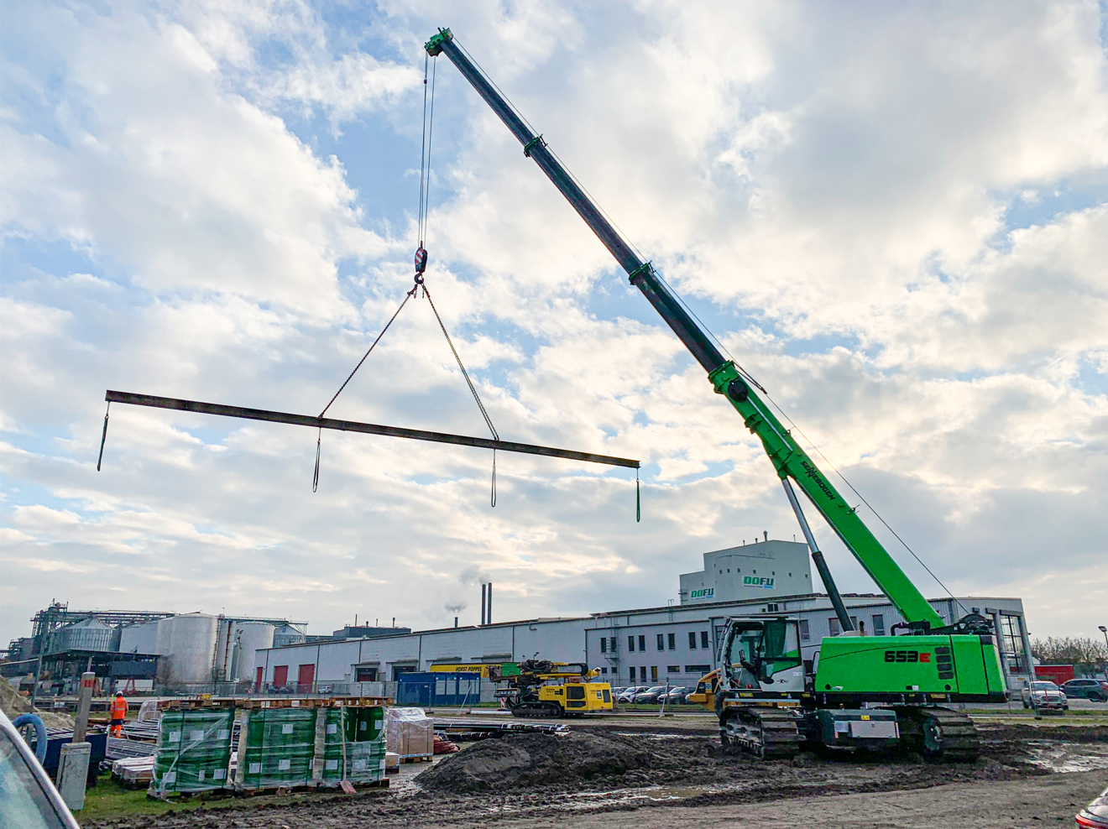
Captions:

Image 1: The 50 t telescopic crawler crane was specially equipped with rubber pads that are gentle on the ground for the work on the quay.

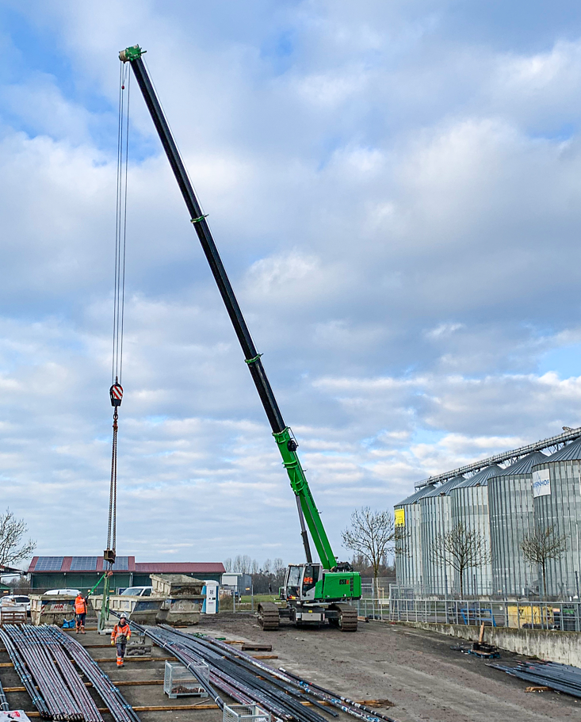
Image 2: In addition to the 11 t debris troughs, the telescopic crane also carries the up to 29.5 m long marine tie rods including spreader beam in pick and carry operation. 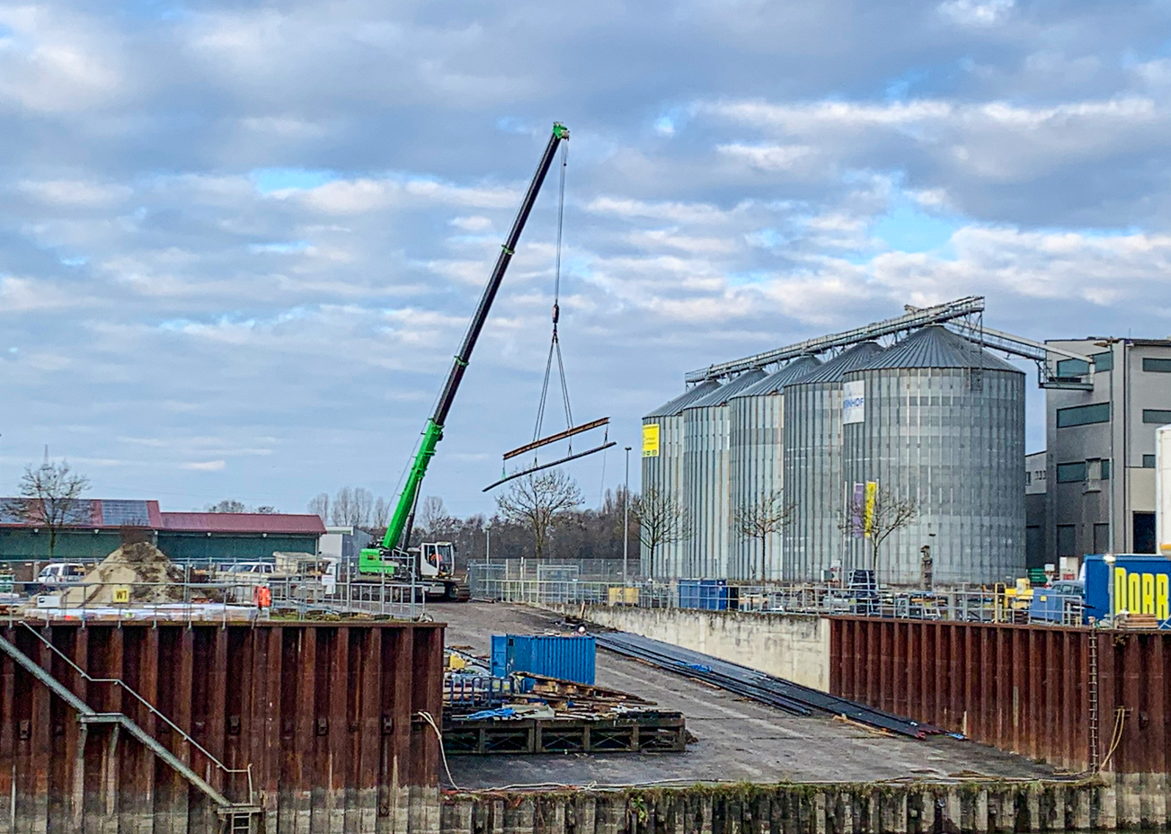
Image 3: On the 20° sloping port ramp, the 50 t telescopic crane moves the delivered materials directly to the edge of the port basin and loads them onto the supply pontoon.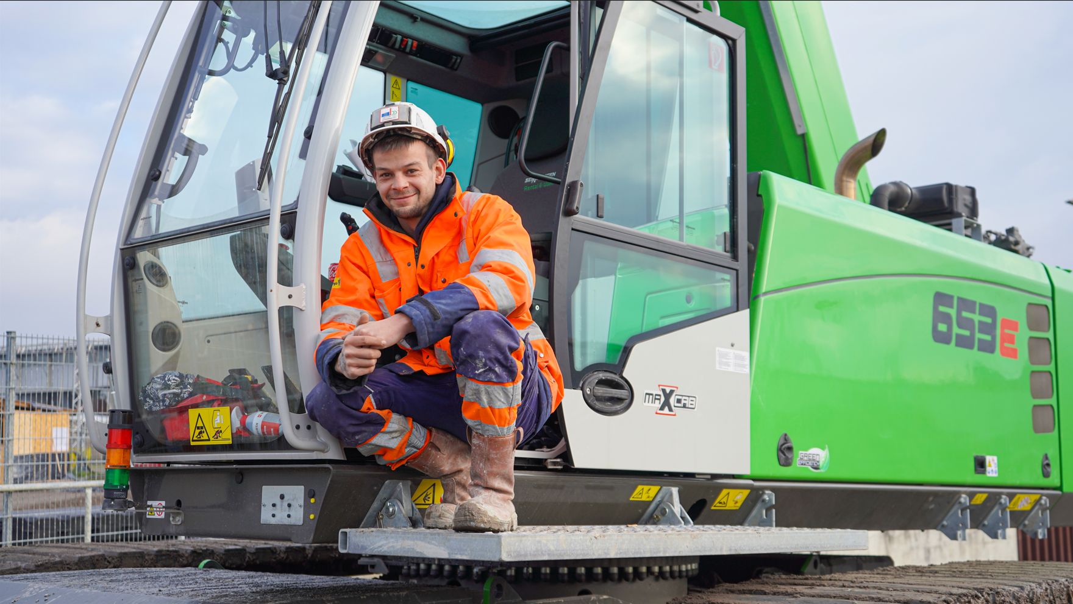
Image 4: Crane operator Tommy Gärtner particularly likes the combination of robustness and flexibility of the SENNEBOGEN 653 E.
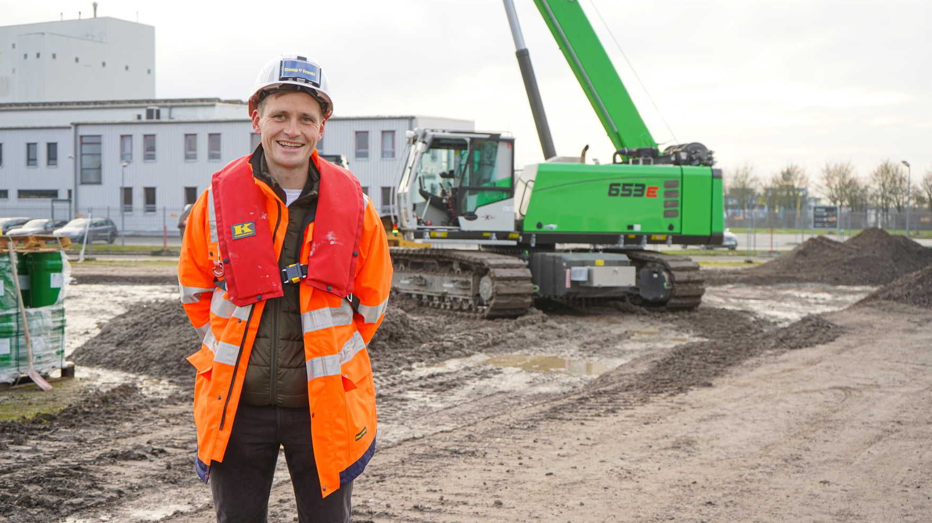
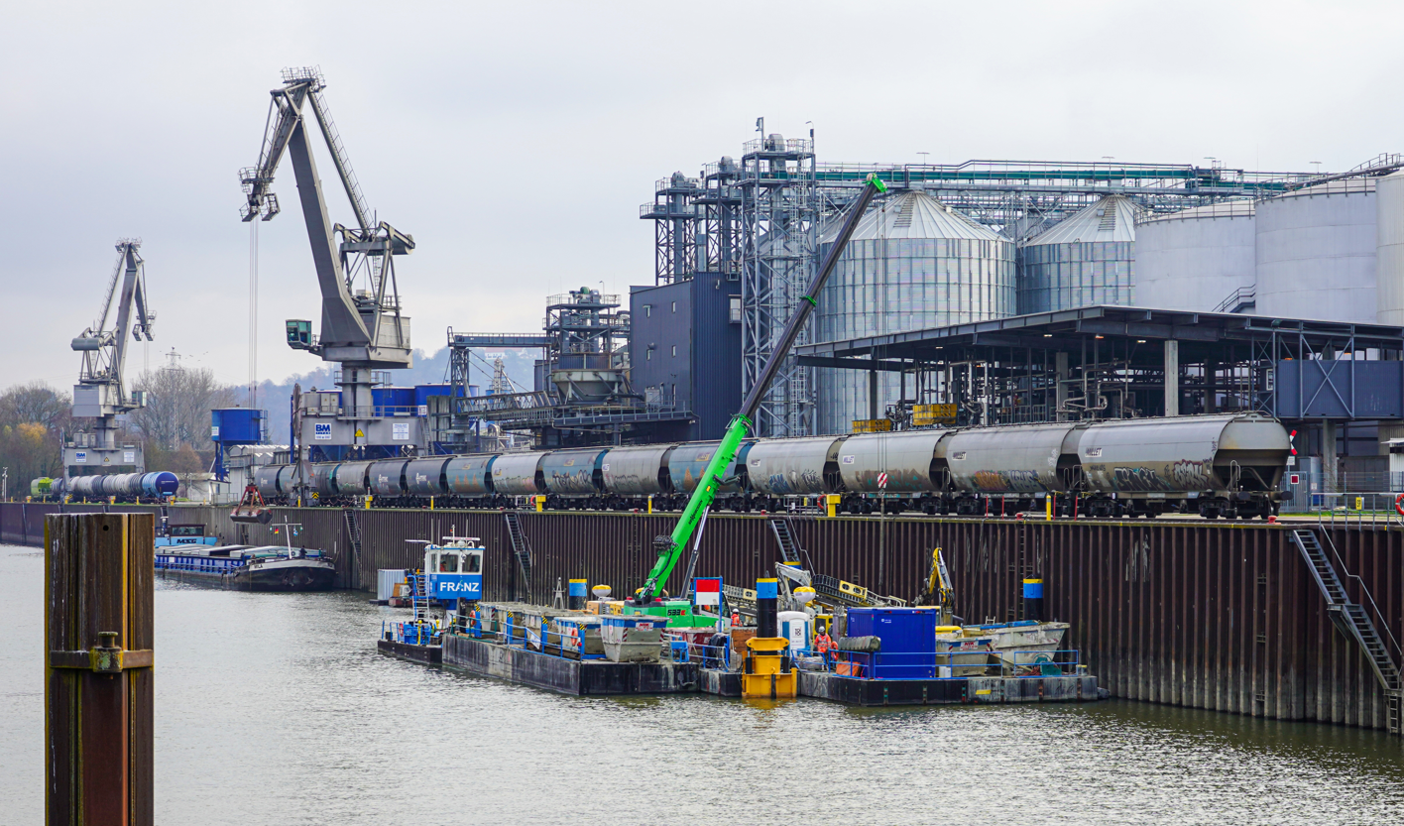
Image 5: Site manager Christoph Müller from Stump Franki is pleased with the reliability of the two telescopic cranes and is highly satisfied with the progress of the project.
Image 6: Thanks to its compact design, the 33 t crawler telescopic crane is perfectly suited as the central lifting device on the floating platform.
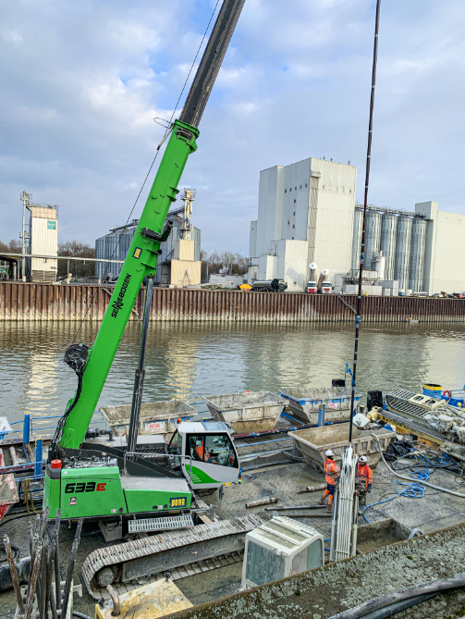
Image 7: With the help of the SENNEBOGEN 633, the tie rods are inserted into the drilling and tie setting device...

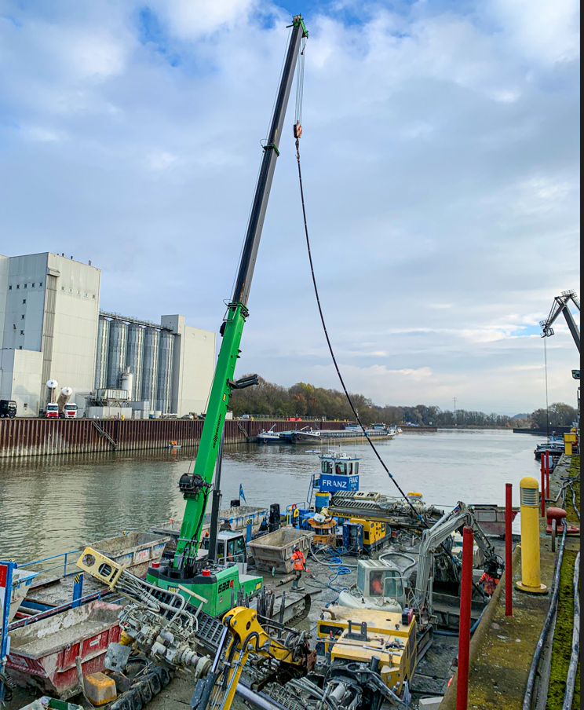
Image 8: ...to be subsequently driven into the quay wall as tiebacks for the port basin sheet pile wall.

