Location Ort: Singapore, SGP
Photo Foto: Jason Ang
Editor Autor: Jason Ang
Date Datum: Apr-23
Challenging viaduct construction, Singapore: Construction of Tampines viaduct over existing roads that are heavily congested
The construction of the new Tampines viaduct presents some challenges. The installation must be completed in a very tight area with not much space to perform the heavy lifting tasks. As an expert in this area, Hwa Seng Builder Pte Ltd (HSB), a leading civil engineering and construction provider, is called for the job relying on a 70 t telescopic crawler crane from SENNEBOGEN.

The new Tampines viaduct in Singapore connects TPE, Tampines Expressway, to PIE, Pan Island Expressway (Tuas) and Upper Changi Road East. It aims to ease traffic congestion in the area by providing an alternative route for motorists. Overall, the new 1.8 km one-way viaduct will improve traffic flow and reduce travel time for residents in and out of the area, making their daily commute more efficient and convenient.

True multi-purpose telescopic crawler crane: SENNEBOGEN 673 E
Because the road is still partially active, there have been special safety requirements for the crane. The SENNEBOGEN 673 has met these regulatory requirements. The lifting tasks include the handling of concrete piles, installation of rebar cages, assembling and dismantling of column formwork in tight active public roads. Therefore, the crane needs to be extremely stable to minimize the need of movement around the jobsite. Additionally, the tight job with concrete barriers surrounding the site requires a small footprint. The prior setting of the “virtual wall”, an added safety function that create swing restriction to SENNEBOGEN 673 E allows the operator to focus on the task at hand and not to worry about the concrete barriers, making the SENNEBOGEN crane perfectly equipped for these delicate operations. Another criterion that led Hwa Seng Builder Pte Ltd to opt for the SENNEBOGEN 673 E for the project. The Full Power-boom that can telescope under load thus avoiding the need to move the for most tasks.

Lifting above the partially active road: Safe lifting achieved through crane stability
The formwork and other materials to be lifted weigh about 2 t each and have odd shapes, that can easily be caught by the wind. These circumstances can complicate the lifting tasks very quickly. Luckily the sturdy 70 t telescopic crawler crane, sitting on a 4.8 m track when fully extended provides maximum stability. Together with the well-built robust boom, swaying activities are greatly minimized.

“A fair amount of my lifting tasks is below 30 m high. The SENNEBOGEN 673 E fits perfectly on the sweet spot between being on the right capacity and boom length that will not cost an excess overweight. A big advantage compared to other crane types which usually have plenty of excess weight.” Tee Ley Shui, Crane Operator.

Quick movement between jobsites: SENNEBOGEN 673 E
Sia Wee Hong Raymond, the logistic coordinator for SENNEBOGEN 673 E explains: “As the columns for the viaduct are in between the main road, we have to move the SENNEBOGEN 673 E telescopic crawler crane almost every day from site to site depending on the lifting schedule, the retractable undercarriage and being able to load up and down the lowbed trailer with its counterweight is indeed a time saver.”

Working together with Raymond Sia is Ce Zhuang from Aly Energy Singapore, the SENNEBOGEN dealer in Singapore. Ce Zhuang actively communicates with Raymond, supporting especially in after sales service.

“ALY Energy has been supporting HSB closely for more than 6 years which give me the confidence in deploying SENNEBOGEN cranes to complicated jobsites.” Sia Wee Hong Raymond, logistic coordinator, HSB.

Photos and Captions:

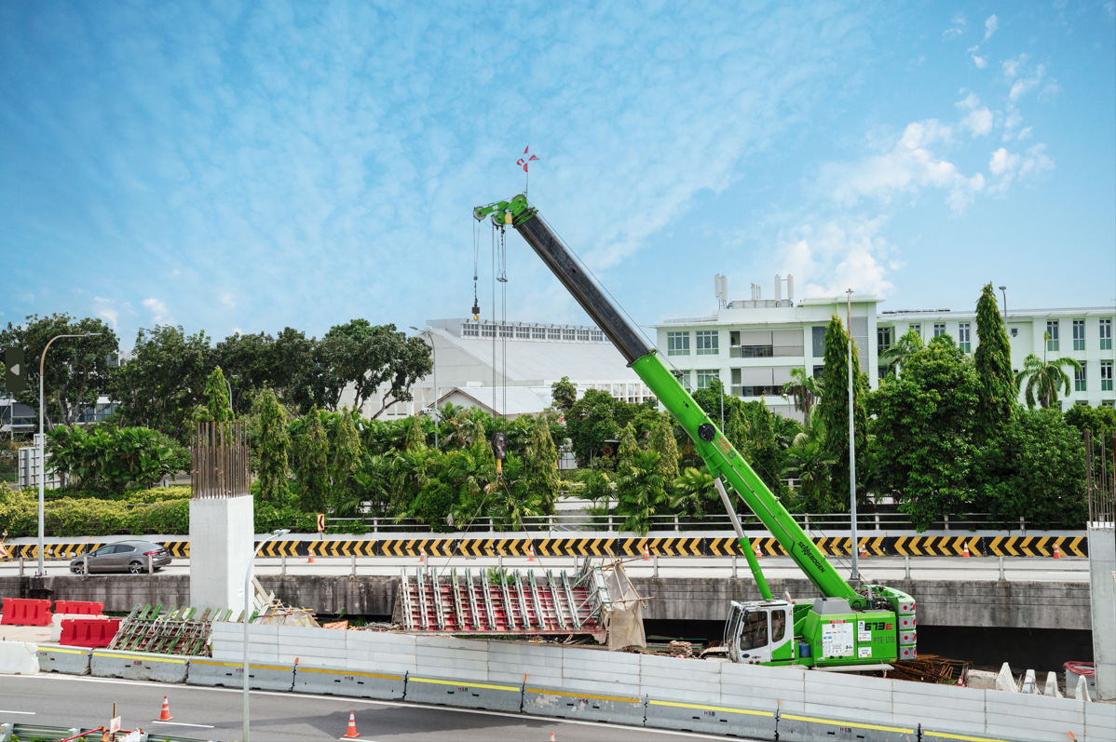
Image 1: Lifting above the road: Safe lifting due to the stability of the 4.8 m long, robust crane with extended crawler undercarriage.

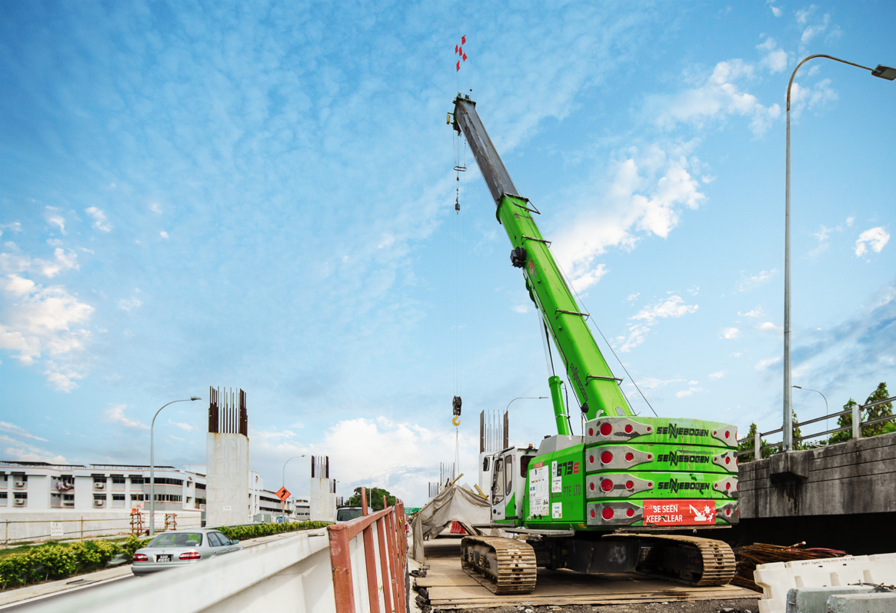
Image 2: The Full Power-Boom enables the operator to make fine adjustments during lifting task while avoiding obstacles.
