Bild:
Editor Autor: Andrea Heinrich-Jobst
Location Ort: Biberach, Deutschland
Date Datum: 23.03.2023

Industrial deconstruction in the production halls of a die casting manufacturer

The SENNEBOGEN 825 E demolition excavator has often proven that it can be used flexibly. However, demolition in the production halls of a die casting manufacturer does not happen every day.
It is dark and cramped. The work to be done far up under the roof of the approx. 1850 m² hall. Thick steel beams support the old industrial equipment, which has had its day and is to be replaced by a new megacasting plant.
Megacasting is a manufacturing process in which multiple components are combined into a single die-cast part. This requires the use of a large casting machine with higher clamping force, allowing larger and more complex parts to be produced. Megacasting has the potential to revolutionise the manufacturing process of various industries.

Demolition excavator in the middle of an industrial hall

The 825 demolition excavator with its long reach is exactly the right machine for the right place. Easy manoeuvrability due to the crawler undercarriage, facilitate the work inside a building. Equipped with demolition tongs and grabs, the individual components are cut through and pre-sorted for recycling. Entire plant housings can be lifted and cut up from the second level of the hall thanks to the long boom of the SENNEBOGEN 825 E.
Steel girders also have to come out of the production hall, which means heavy loads also have to be moved.
The demolition excavator 825 E from SENNEBOGEN can be used individually in many places. Its compact design offers optimal manoeuvrability. A long reach enables work from a safe distance, especially when the machine is working at a high height.
The controlled dismantling, which was carried out by the company Max Wild Gmbh, was completed in May, because the new megacasting plant is to go into operation from the end of the year.
The machine operator was visibly enthusiastic about the machine from SENNEBOGEN: "The machine is really easy to operate. It responds to the finest impulses. It is particularly easy to work at height with the Sennebogen." With the cabin, which can be raised and also tilted, the operator always has a safe view of the working tool and the surroundings."

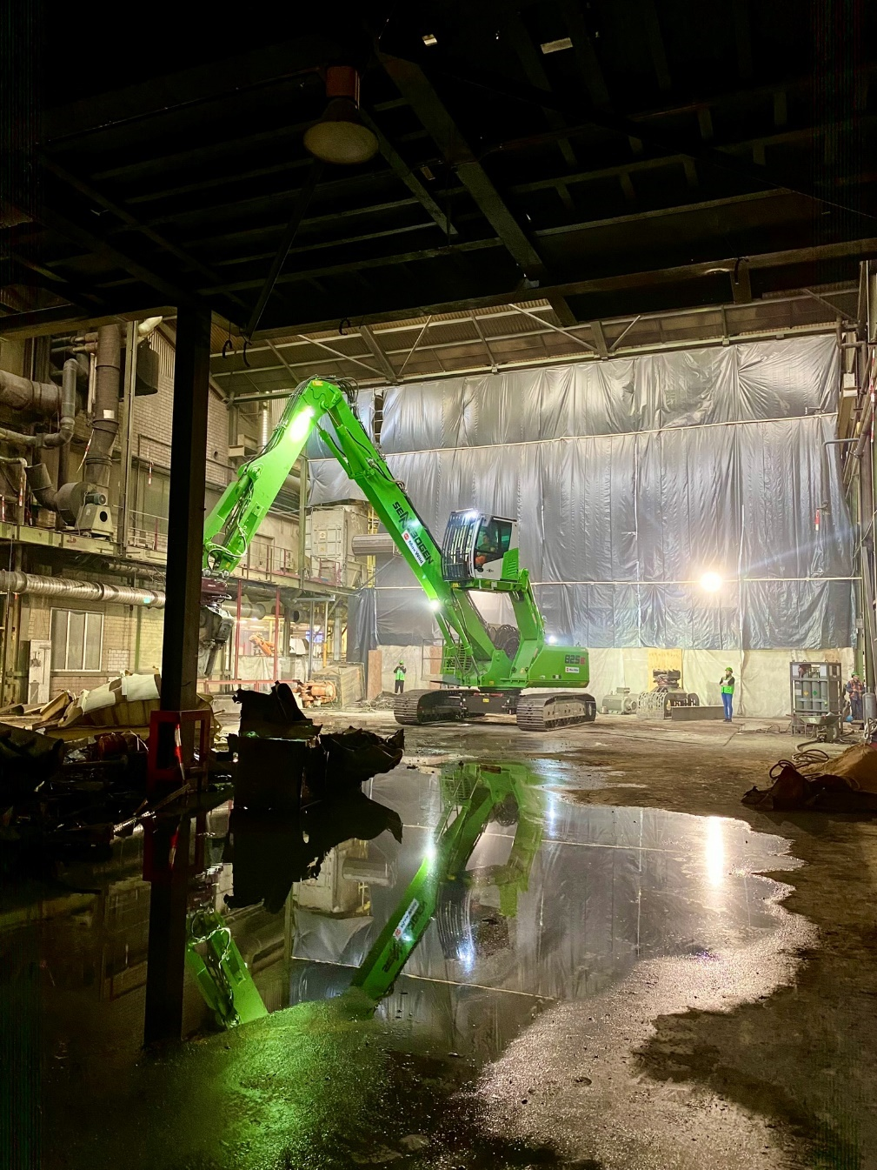
Working in confined spaces. No problem for the 825 demolition excavator from SENNEBOGEN.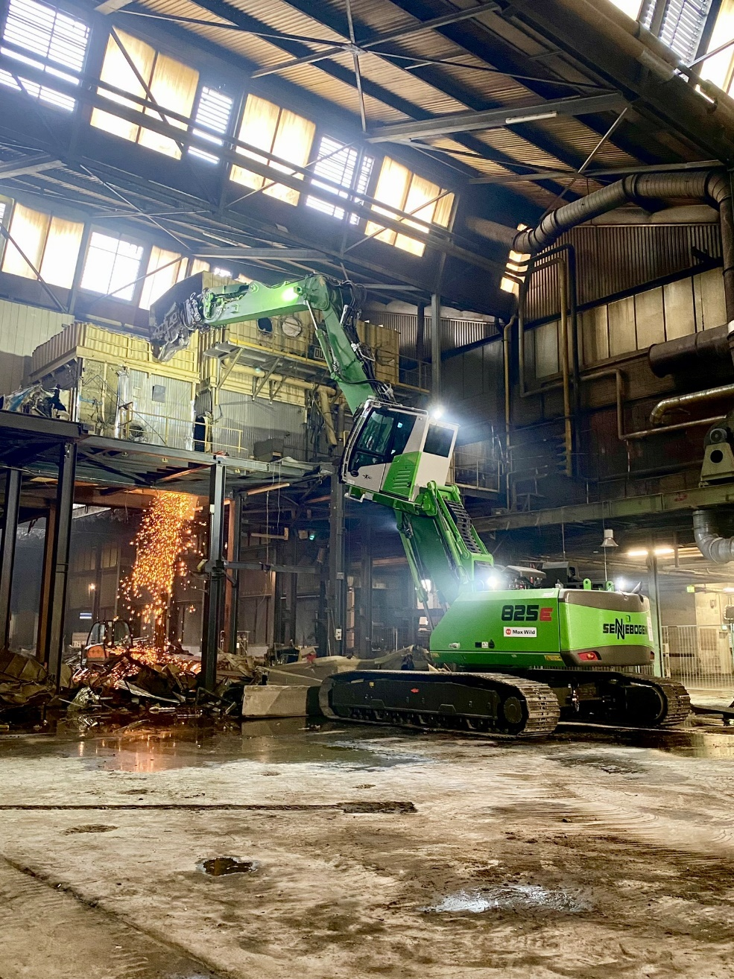
Selective deconstruction also for work at height.

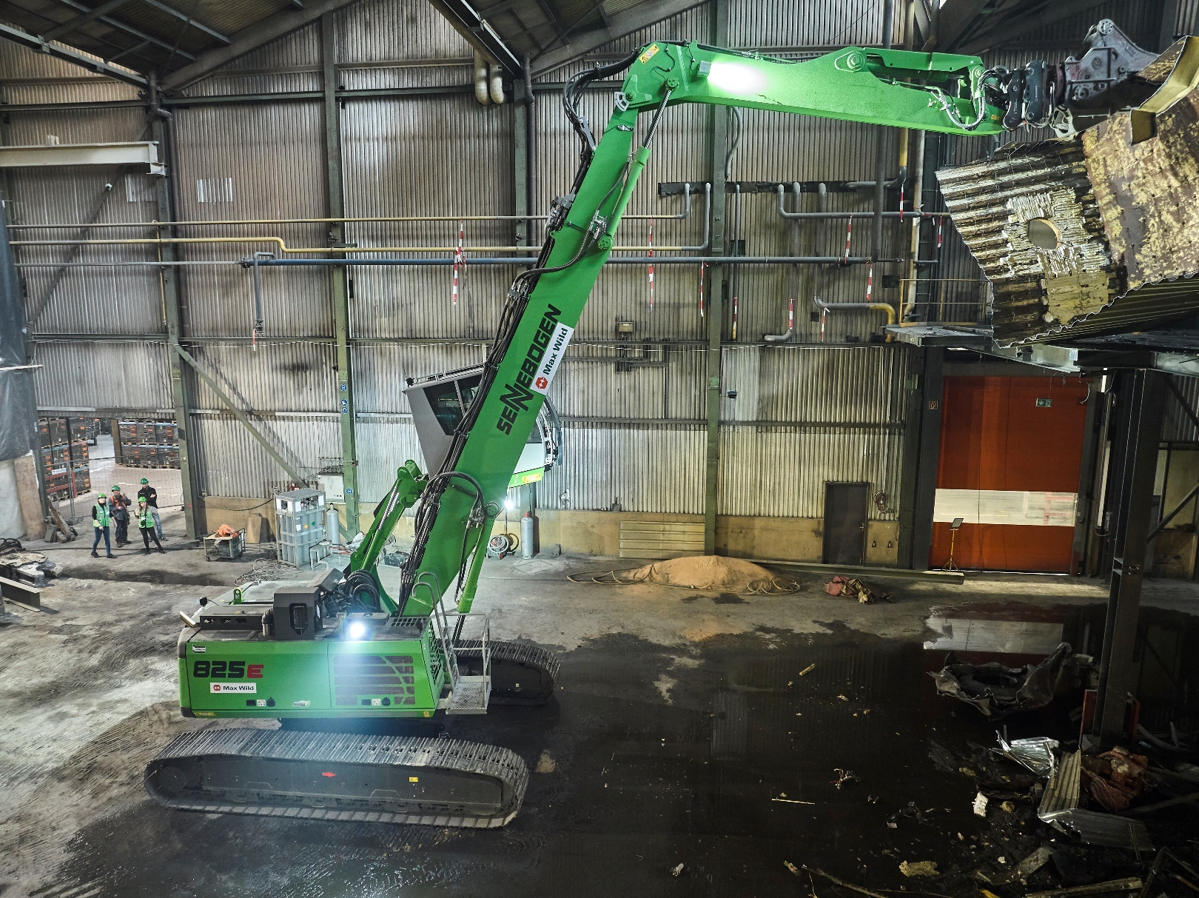
Long reach of the boom enables selective dismantling even under the hall roof.

[Kommentar: Menschen raus retuschieren]

