Bild:
Date Datum: Juli 2022
Location: Molise, IT
Photo Foto: Cesaro Mac Import
Editor Autor: Ceasaro Mac Import

Tree care handler in Italy: ideally equipped for tree felling along country roads, highways and river banks

Dr. Multiservice, a company specialized in green and landscape maintenance in cooperation with municipalities and public administrations, is ideally equipped for tree felling along roads in the region of Molise in Italy with a SENNEBOGEN 718E tree care handler in their company fleet.

Dr. Multiservice was founded in 1993 as a family business and has been growing steadily with several locations across the regions of Molise, Modena and Puglia. The company's fleet now includes over 100 machines which for some time now has also included a SENNEBOGEN 718 E tree care handler. Giovanni Perrotta, Managing Director of Dr. Multiservice, decided in favor of the 718 E after extensive market research: "Our contact Cesaro Mac Import made it possible for us to visit other SENNEBOGEN machines and so we were able to convince ourselves of the quality and the good service."

Wide range of applications for tree care handlers
The machine is now used for a variety of purposes, mainly for tree felling along roads and river banks and in parks and gardens. Thanks to the installed 4-point outriggers and an additional stabilizer blade, optimum stability is also ensured in off-road terrain. Feeding shredders with green waste is also one of the tasks of the 718 E at Dr. Multiservice. If the tree care handler is working along roads, Perrotta sees the big advantage in the small space requirement, among other things: "The machine has a maximum width of 3.90 meters including the extended outriggers. When working on country roads or highways, this means that ongoing traffic is hardly restricted, as a single-lane road closure is often sufficient."

Separate hydraulic system convinced Dr. Multiservice
A special feature of the SENNEBOGEN tree care handlers is the hydraulic system consisting of two separate hydraulic circuits, each supplying the boom and the attachment. This allows the machine to work particularly powerfully and makes it suitable for operations both along roads and in urban areas. Perrotta emphasizes that work can now be carried out much more efficiently and safely for the staff. The operator can grab the tree trunks with the grab saw, saw them off and then deposit them to the side in a controlled manner or directly feed a chipper. He is always safe in the elevating cab, which also gives him an improved view of the entire work area. The more risky work with chainsaws or work at heights is no longer necessary.

[Caption:]

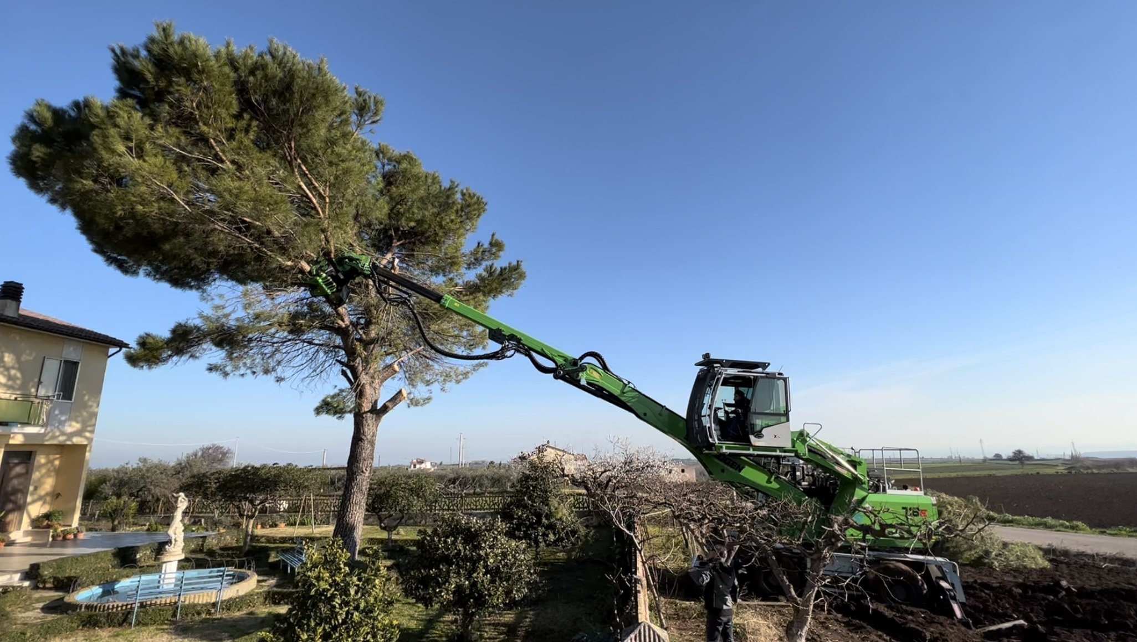
Tree felling with the 718 E in gardens and parks

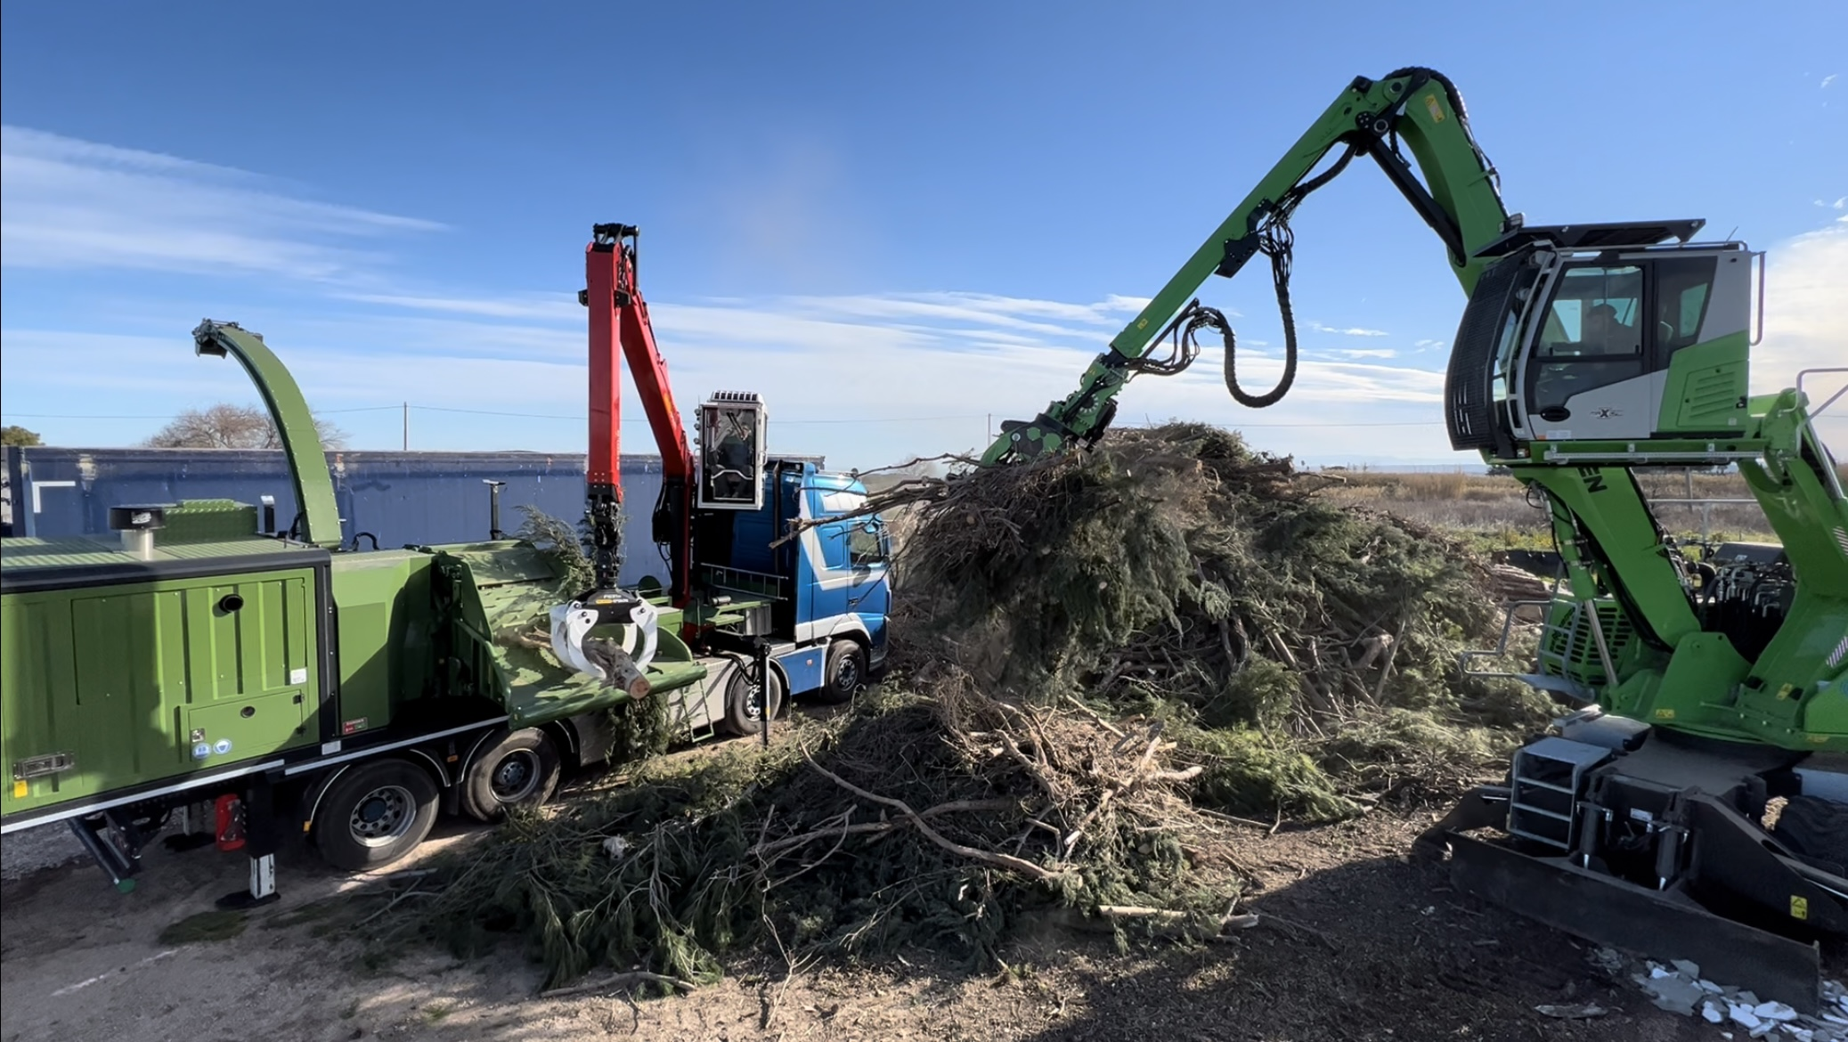
Further processing of green waste: Feeding a shredder with the 718 E
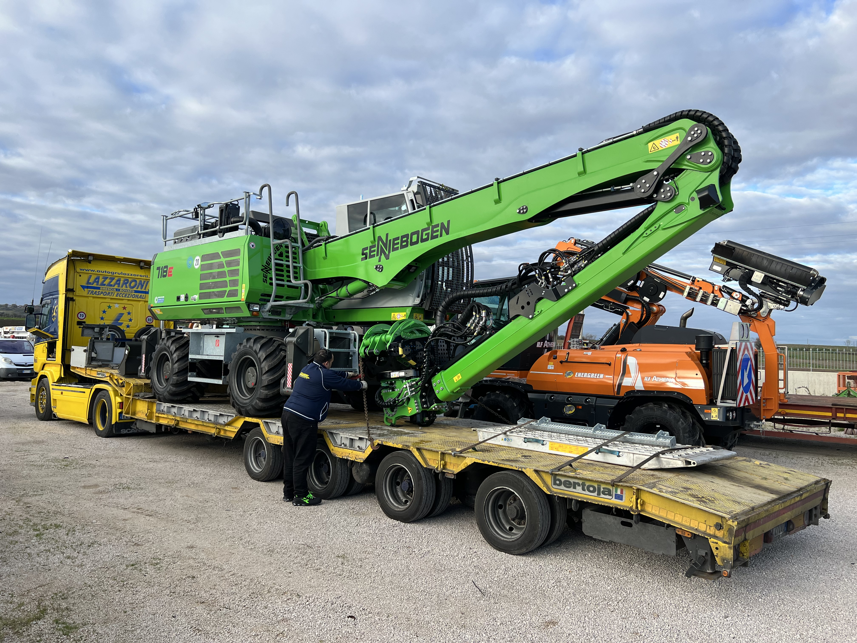
Easy transport of the tree care handler by flatbed trailer thanks to small transport width

