Editor Autor: Franziska Limbrunner
Photo Foto: Stefan Hanke
Location Ort: Lillois, BE
Date Datum: Apr-23
RER urban railway extension in Belgium: Telescopic crane builds concrete tunnel

An infrastructure construction project of impressive dimensions is currently being carried out south of Brussels. For the expansion of the Belgian RER urban rail network, the line between the Nivelles and Lillois stations is to be extended from two to four tracks. For this demanding project in infrastructure construction, the contracted construction company Galère relies on the flexible 40 t telescopic crawler crane from SENNEBOGEN.

Galère occupies a leading market position in Belgium. They have now been commissioned for various infrastructure construction measures as part of the expansion of the Belgian urban rail network. The company also owns a number of mobile telescopic cranes and duty cycle cranes from SENNEBOGEN, but for the work along the railroad line the company is specifically using the 40 t 643 E telescopic crawler crane. This crane's excellent maneuverability and stability - without any additional support and with an inclination of up to 4 degrees - make it perfect for working on rough terrain. Its 30 m long Full Power Boom can be continuously telescoped even with a load on the hook, enabling optimum load capacities at any boom length. In combination with the particularly strong, hydraulically telescoping crawler undercarriage, this makes it the perfect pick and carry crane for such construction sites along railroad lines.

Construction of a sewage tunnel for the future urban railroad line
In total, the urban rail project is scheduled to take a good 9 years and should be completed by the end of 2029. At Lillois, Galère is working in a joint venture with Jan de Nul to build a concrete tunnel under the new four-track line. This is needed so that the water accumulating in the embankment can be diverted under the tracks. In addition to lifting and placing the reinforcement mats and the formwork panels, the 40 t crane is primarily called upon when it comes to laying the steel pipes, which can weigh up to 5 t. These are to temporarily drain off the water before the construction of the tunnel is completed and must therefore be carefully inserted under the concrete structure. No problem for crane operator David Philippot – also thanks to the intuitive and sensitive control of the telecrane: "I already liked driving the SENNEBOGEN 630 HD in the past and now I really like working with the 643 E. The machine works extremely sensitively and the new SENCON control system is really top! I find it very clear how the status of the machine is displayed and how the load moment limiter works."

Operator comfort complimented
Philippot also has words of praise for the operator cab Multicab, which can be tilted by 15 degrees as standard: "The cab is very spacious and comfortable. All the controls are within easy reach and you always have a good view of the load, no matter how high it hangs on the hook. At greater heights, I can simply tilt the cab back and sit back in a relaxed position so that I can concentrate fully on the crane lifts."

Captions:
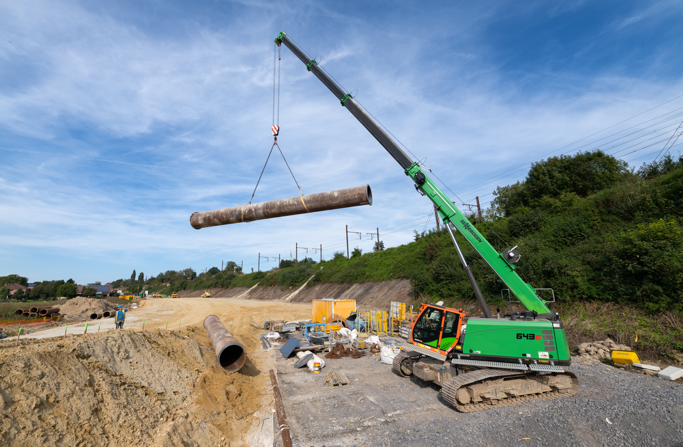
Image 1: The 40 t telescopic crawler crane picks up the steel pipes, which weigh up to 5 t, and delicately lays them under the concrete structure.
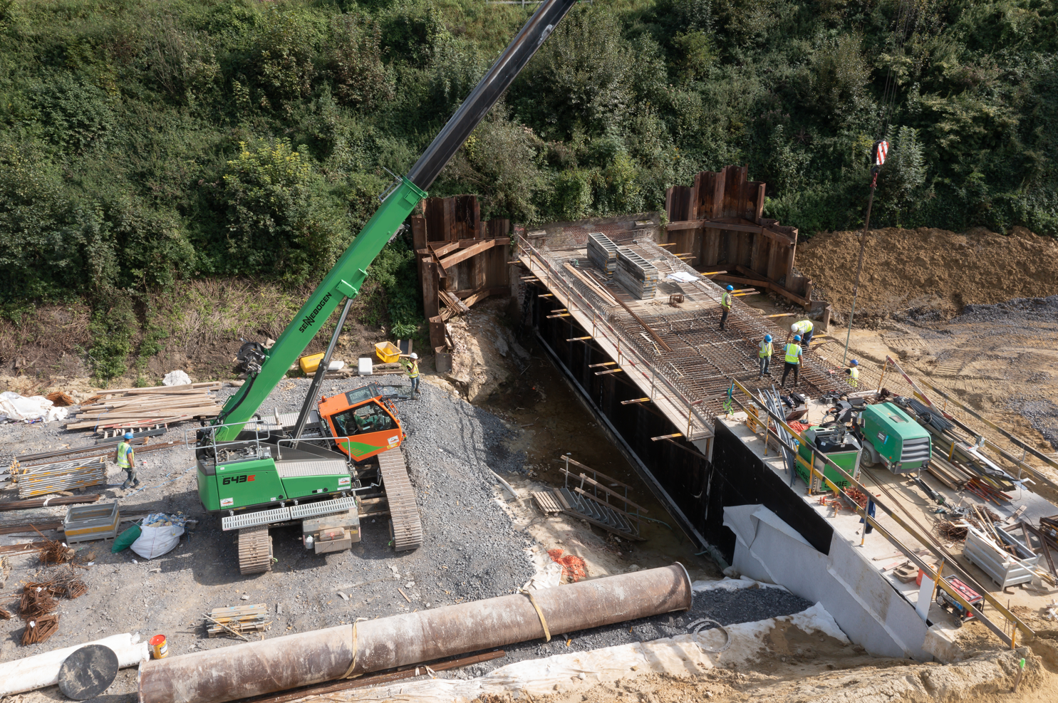
Image 2: The continuously telescoping 30 m full power boom can also be used for precise lifting work at greater distances, which is not uncommon in the railway extension project.
Image 3: Crane operator David Philippot enjoys working with the flexible 40 t telescopic crawler crane.

