Photo Foto: Dr. Franziska Limbrunner, Jessica Hennek
Date Datum: Mai-23
Location Ort: Piombino, IT
Editor Autor: Dr. Franziska Limbrunner
Pipeline construction: Construction of a new liquid gas terminal with 80 t telescopic crawler crane

As part of the national energy plan to diversify Italy's gas supply, a new LNG (“Liquified Natural Gas“) terminal is currently being built in the Tuscan port city of Piombino. The main contractor for the pipeline construction is the Italian subsidiary of Max Streicher, which is using the brand-new SENNEBOGEN 683 E 80 t telescopic crawler crane for the large-scale project.

The LNG terminal currently under construction in Piombino will handle liquefied natural gas transported to Italy by ship from all over the world in the next few years and feed it into the Italian gas network. Every year, around 5 billion cubic meters of gas are expected to arrive here, covering 6.5% of the national demand. In addition to gas storage facilities and equipment for unloading the tanker, which converts the liquefied gas into its gaseous state while it is still on board the ship, kilometer-long pipelines must be laid first and foremost to transport the gas to the injection point into the national network some 8.5 kilometers away. The contractor Max Streicher S.p.A. not only has many years of experience in pipeline construction and plant engineering, but also specializes in the gas and oil sectors. It is also known for its use of innovative technologies and adherence to the highest safety and quality standards. For this project, they are now using SENNEBOGEN's brand new 80t crawler crane, which they were supplied with by ESPI Engineering, SENNEBOGEN's Italian sales and service partner. In just a few months, the contractor has already completed 80% of the work using the 683 E as the central lifting device. The plan is to fully commission the LNG terminal in May.

SENNEBOGEN 683 E - All-rounder in pipeline construction: from pick and carry to precast assembly
The SENNEBOGEN 683 E is a robust telescopic crawler crane designed for challenging construction sites like this one. This is because the large-scale project several kilometers long on the Italian west coast is to be implemented in the shortest possible time. The flexible 80-tonner is literally on the job from start to end - from the ship's dock to the injection point - and handles all the lifting work. This includes first and foremost the laying of the pipe components, with the heaviest part, a line filter, weighing 32 t, but also includes the handling and assembly of precast concrete parts for the construction of the service and control building, in which the gas supply to the national grid is controlled. The advantage of the new telescopic crawler crane on this pipeline project is that it easily copes with the rough terrain there. With its telescopic crawler undercarriage, it simply moves itself along with the construction site from section to section. In tight spots, the track width can be flexibly reduced from 4.2 m to as little as 2.68 m while the machine is still in motion. In addition, in pick-and-carry operation, it can even travel with 100% of the specified load on the hook and is therefore able to pick up the pipes and precast concrete parts from the transport frame, bring them directly to the assembly site and install them there straight away. Its telescopic boom – a continuously telescoping 43 m long full power boom – which can also telescope with load on the hook, also gives flexibility and speed in lifting and laying operations where a greater distance from the pipe trench is required. This also applies when the crane is inclined up to 4 degrees. On the whole, the greatest outreach so far was 42 meters with loads of about 1,5 t for concrete plinths and line flow meters. In this way, one pipe component after the other can be precisely brought into position and fast construction progress achieved.

„Tutto bene“ – Crane operator compliments performance and safety
Crane operator Raffaele Abbruzzese from Max Streicher S.p.A. has already worked with several cranes from SENNEBOGEN. His conclusion on the brand new 80 t telescopic crane: "The 683 E has strong winches, high lifting capacities over the entire working range and is easy to operate. In addition, I always feel safe because it is very stable, even in inclined positions. So: tutto bene!"

Captions:
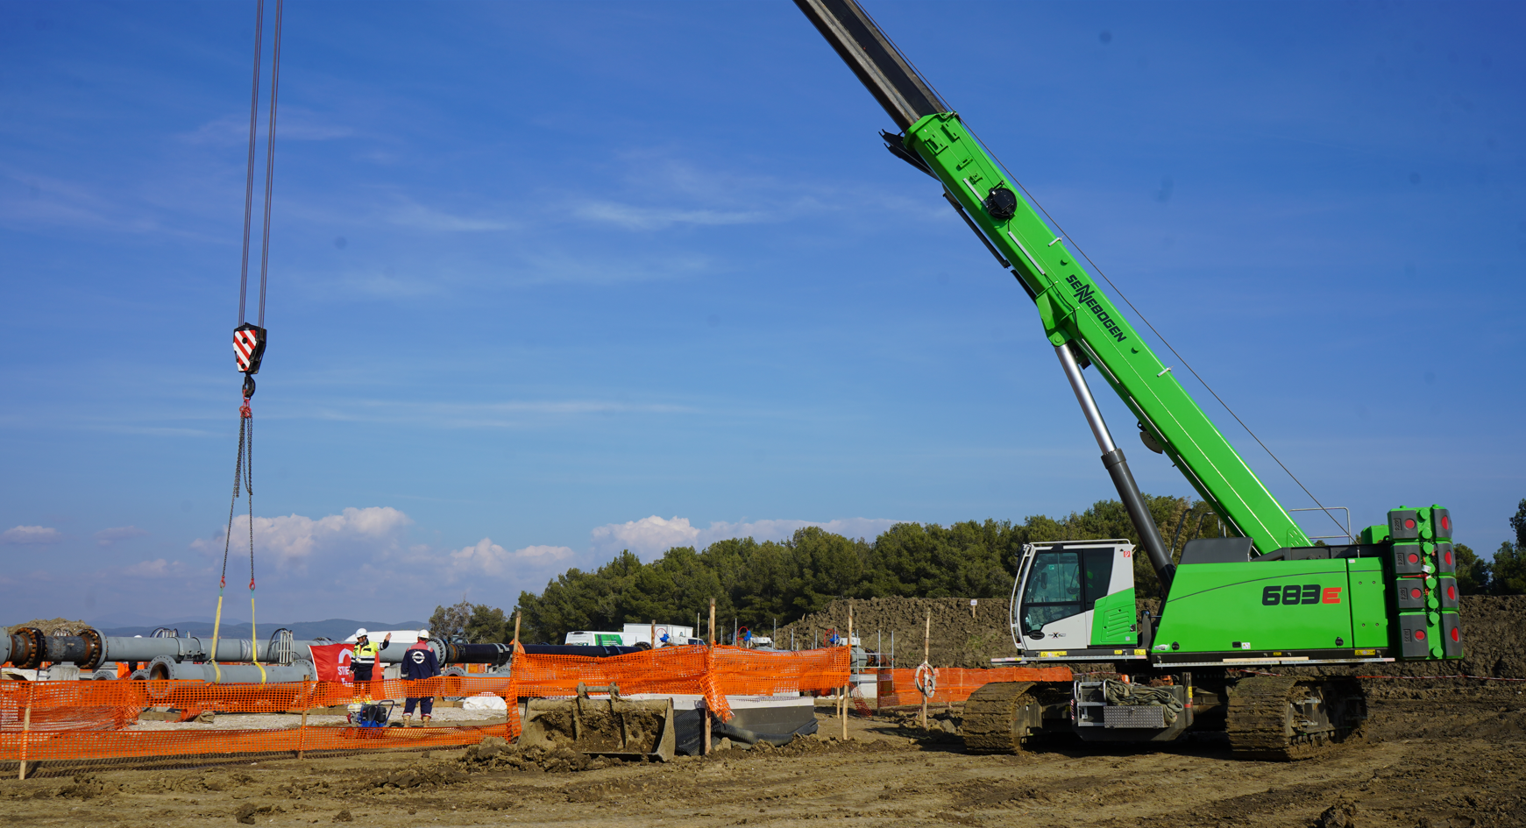
Image 1: With its continuously telescopic full power boom, the 80 t telescopic crawler crane precisely and quickly assembles the steel pipes, which weigh up to 11 tons.

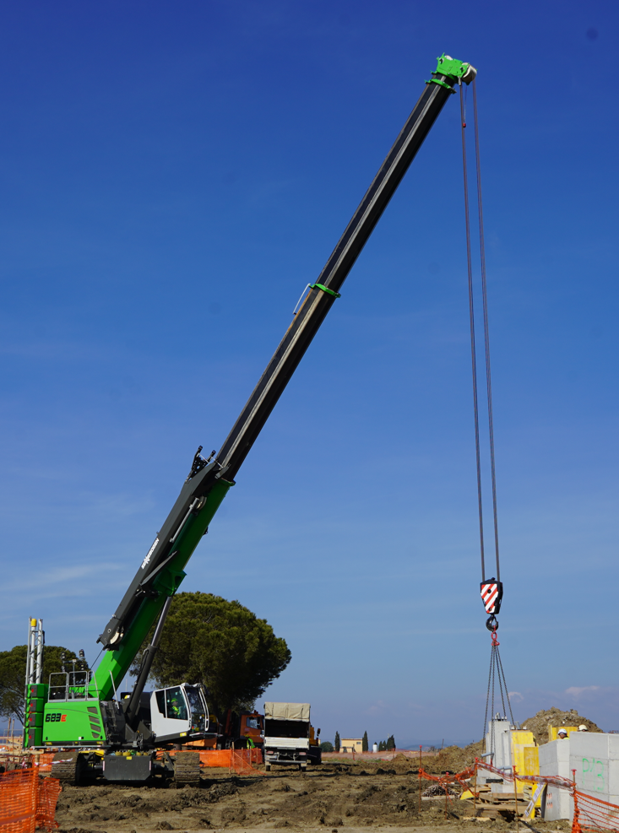
Image 2: In addition to laying the pipeline, the telecrane also takes care of assembling the control building at the injection point.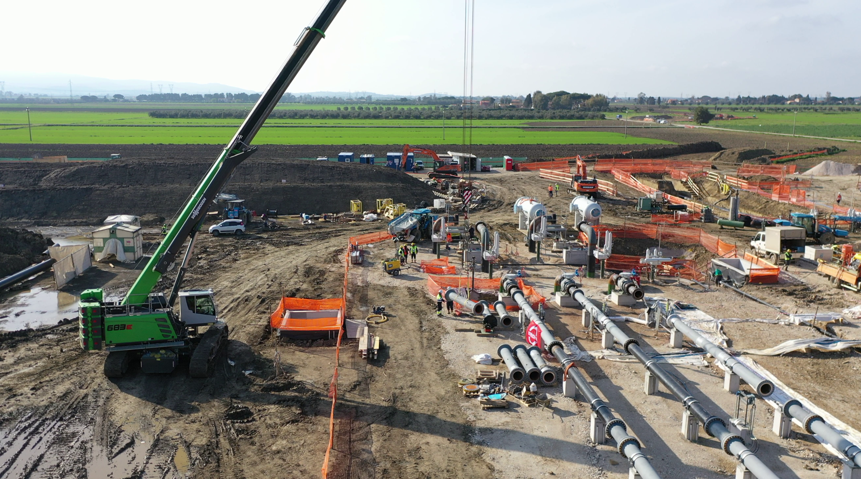
Image 3: The new 80-tonner easily masters rough construction site terrain thanks to its robust and powerful crawler undercarriage and has high payloads even at inclinations of up to 4 degrees.

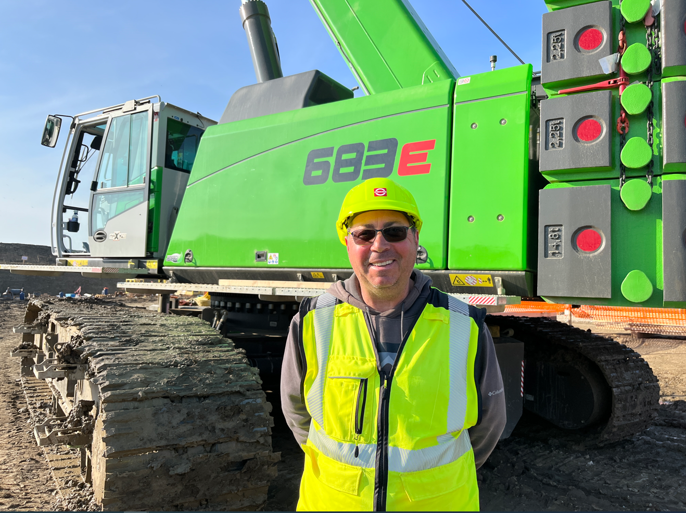
Image 4: Crane operator Raffaele Abbruzzese particularly likes the safety and performance offered by the new telescopic crane from SENNEBOGEN.

More jobsite pictures:
