Bild:
Location: Weißenohe, DE
Photo Foto: Sandra Hartl
Editor Autor: Sandra Hartl
Date Datum: 06/2023

Ash dieback: deadwood removal with tree care handler 718 E

Bald spots to dead roots: ash dieback is causing numerous, challenging operations in the field of tree felling and traffic safety. The use of SENNEBOGEN tree care handlers is proving to be a particularly environmentally friendly and efficient option for the removal of rotten deadwood at the company Messingschlager from Franconia in Germany.

In Asia, a harmless leaf fungus - in Europe, a major plague for nature: for many years, an imported fungus has been causing ash dieback. Especially in summer, the leaves of the ash tree are infected first, before the pathogen leads to the death of the sprouts. So far, no practical measures are known to contain the fungal infestation. Ash trees in which the crowns are visibly heavily infested or the base of the trunk shows necroses must be removed quickly along traffic routes for safety reasons.

Time and cost savings through the use of SENNEBOGEN tree care handlers
The ash dieback is also having a strong impact in Upper Franconia. Managing director Sven Messingschlager has therefore decided to expand his fleet with a SENNEBOGEN tree care handler 718 E from SENNEBOGEN Vertriebsgesellschaft in order to implement, among other things, complex tree felling operations in the future as part of the deadwood removal caused by the ash dieback. In addition to his original focus, the timber trade as well as forestry services, Messingschlager can now take on an even broader range of services in the area of traffic safety, tree care and hazardous tree felling. "I have many customers where I previously had to use aerial lifts and harvesters for hazardous tree felling due to the complexity of the operation. With the 718 E, I can handle such operations in a much more cost-efficient, safe and pleasant way for the customer. Time savings also play a major role for my customers, especially when roads have to be closed," says Messingschlager.

Safe and efficient use: deadwood removal in a nature conservation monument
Messingschlager completed one of the first jobs with its new 718 E in the area of the "Lillachtal" natural monument in Franconia. In the spring, a fatal accident occurred along a hiking trail due to a falling branch. A large number of dead ash trees had to be removed as quickly as possible. The operation was complicated by challenges, such as a narrow hiking trail that made it impossible to use other machines, such as harvesters. "Especially here in this area, we had to choose the most nature-friendly option for felling the trees. With a machine width of just under 3.5 m inclusive the outriggers, the 718 E just barely fit on the narrow hiking trail. Anything else would have been impossible for us," Sven Messingschlager points out.

Next to the hiking trail stretches the Lillach limestone tufa stream, a millennia-old watercourse that is home to many rare and endangered animal and plant species. To protect the natural monument, a felling method had to be chosen that avoided all contact with or alteration of the watercourse. Messingschlager explains that the use of rope technique would have been a possible, but more inefficient alternative: "With rope technique, we would never have been able to leave the stream course without any impairments. In addition, the operation would have been more expensive and also more dangerous for our employees. The 718 E has the necessary reach that we could cut the trees from the trail and deposit them across the creek to the other side."

[Caption]:
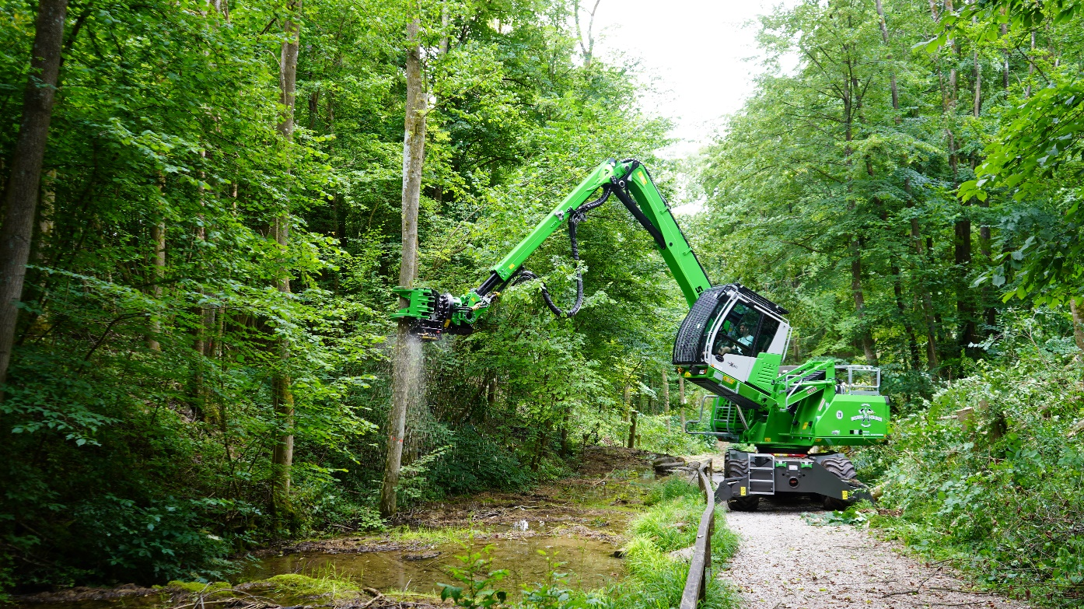
The 718 E tree care handler succeeds in felling the ash trees without impairing the course of the stream
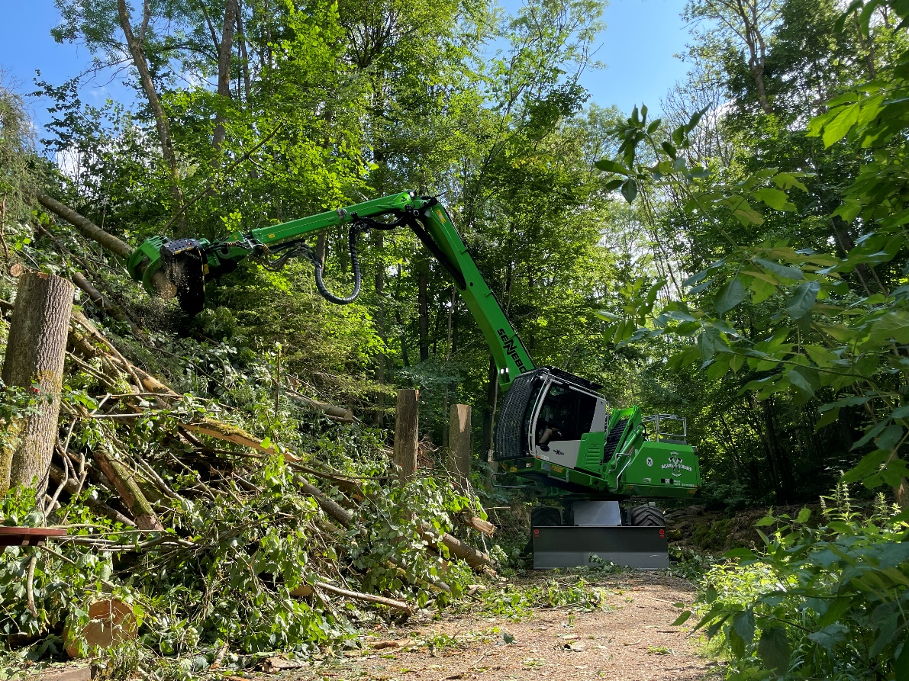
Limited space: the 718 E can also be used on narrow terrain due to its minimal width
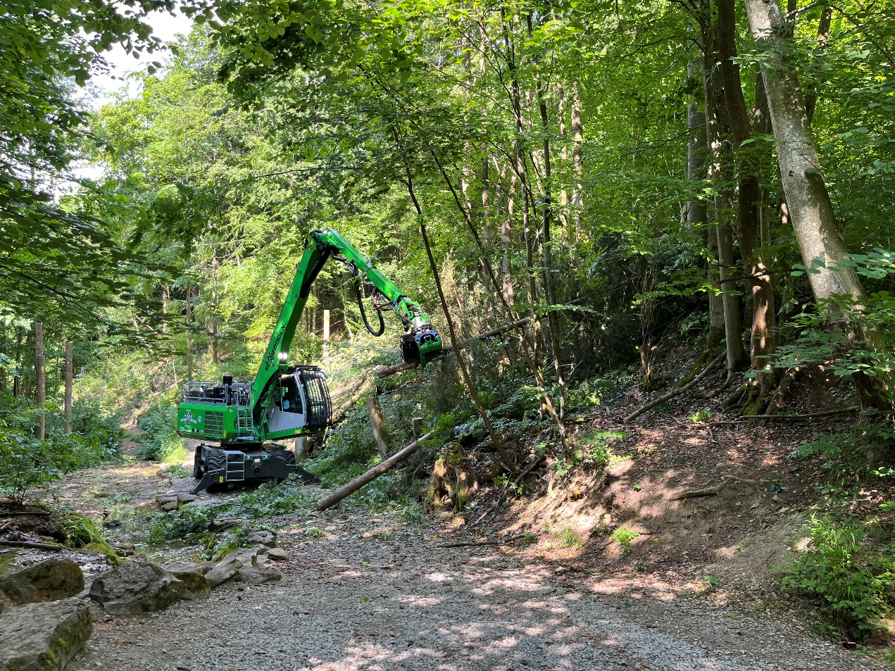
Effects of ash dieback require the use of SENNEBOGEN tree care handlers

